Student Enrollment & Course Management System (SECMS)
PROJECT TITLE | : | Student Enrollment & Course Management System (SECMS)
TEAM ID | : | 6ab37474f82c16391d5a7e9a
TEAM LEADER | : | MU. GOPIKA
NM ID | : | b5eb75a7c281ff6a5d84879fecbd4e4b
TEAM MEMBER1 | : | V. SAVITHA
NM ID | : | 132F280CЕСОВ4Е7B6364A435BF43E961
TEAM MEMBER2 | : | V S. VISHVA
NM ID | : | 3cd18b343eb4d2bb0b14955f65d49c9e
COLLEGE CODE | : | 207
COLLEGE NAME | : | KING NANDHIVARMAN COLLEGE OF ARTS & SCIENCE
UNIVERSITY NAME | : | THIRUVALLUVAR UNIVERSITY
DEPARTMENT | : | BCA - COMPUTER SCIENCE
SEMESTER | : | V
DATE | : | 29/09/2026

STUDENT NAME | : | MU. GOPIKA
YEAR | : | III
COLLEGE CODE | : | 207
COLLEGE NAME | : | KING NANDHIVARMAN COLLEGE OF ARTS & SCIENCE
UNIVERSITY NAME | : | THIRUVALLUVAR UNIVERSITY
DEPARTMENT | : | COMPUTER SCIENCE
SEMESTER | : | V
ROLL NO | : | 20724U09002
NMID | : | B5EB75A7C281FF6A5D84879FECBD4E4B
DATE | : | 29/09/2026
Email ID | : | gopikathellar@gmail.com
PROJECT TITLE | : | Student Enrollment & Course Management System (SECMS)

Student Enrollment & Course Management System (SECMS)

User Story:
The Student Enrollment & Course Management System is a comprehensive Salesforce application designed to streamline and automate the academic enrollment operations of an educational institute. This system enables administrators, enrollment officers, and instructors to efficiently manage student records, course offerings, enrollments, instructor assignments, approval processes, payments, and reporting—all within a unified Salesforce environment.

1. INTRODUCTION

1.1 Project Overview :

This project aims to centralize all student, course, and enrollment-related data within a single Salesforce application to ensure easy data access, structured workflows, and accurate reporting. The system allows Enrollment Officers to manage student admissions, course registrations, and communication effectively, while instructors and administrators gain full transparency into course allocations and academic progress. The solution also enables automated instructor assignment, task creation, validation checks, and multi-level approval processes for enrollment management.

With Salesforce Flows, Approval Processes, Validation Rules, Reports, and Dashboards, the organization can ensure that all enrollment operations—from admission to course completion—are handled systematically and with continuous monitoring of key performance indicators such as enrollment volume, revenue, student status distribution, and pending approvals.

1.2 Purpose :

The primary purpose of SECMS is to replace manual and fragmented enrollment processes with a scalable, automated, and secure Salesforce solution that ensures:

Accurate student data management
Structured enrollment workflows
Automated approvals and validations
Transparent reporting and monitoring

2. IDEATION PHASE
2.1 Problem Statement (Customer Problem Statement Template)

PS | I am (Customer) | I’m trying to | But | Because | Which makes me feel
PS-1 | Enrollment Officer | manage student enrollments efficiently | enrollment data is scattered | systems are manual and unintegrated | frustrated and error-prone
PS-2 | Administrator | track enrollments and revenue | reporting is delayed | data is not centralized | uncertain in decision-making

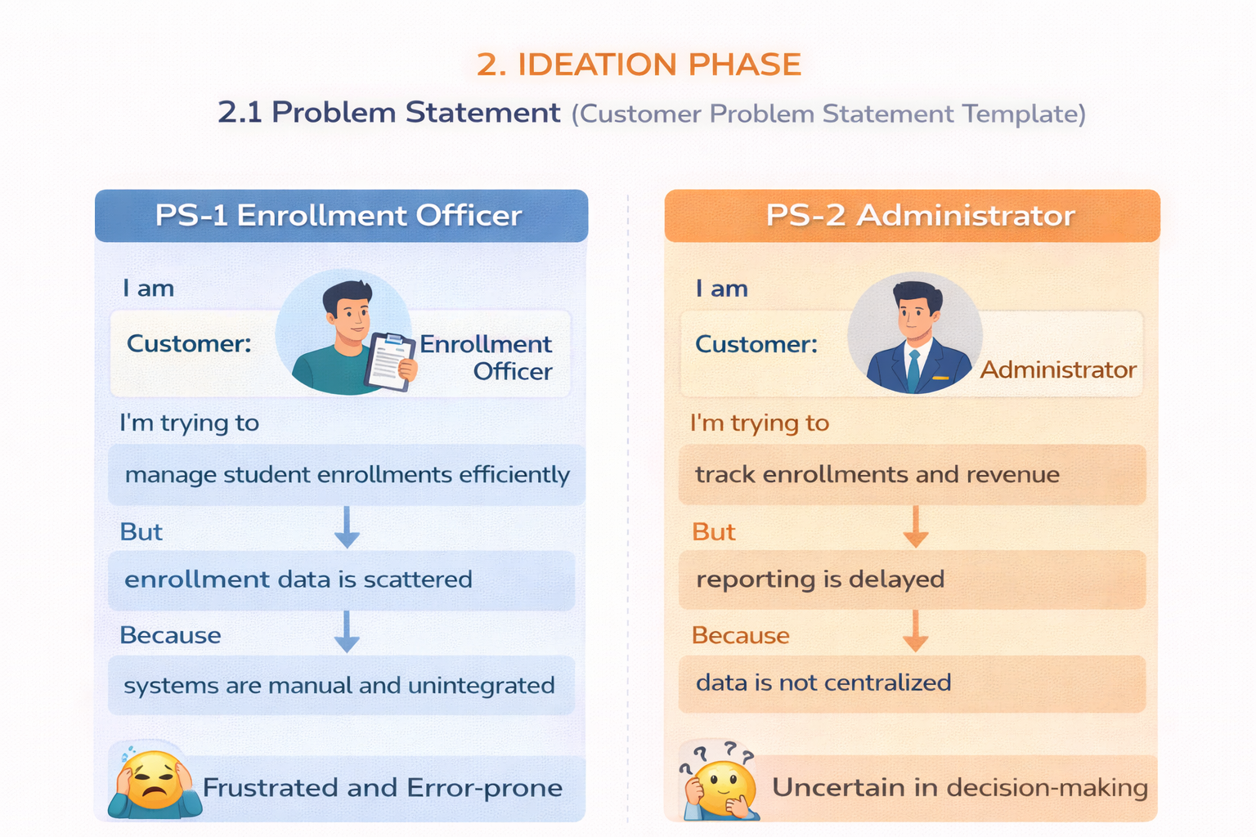

2.2 Empathy Map Canvas
User Persona: Enrollment Officer
- Think & Feel: Concerned about double bookings and revenue loss
- Hear: Complaints from students and management
- See: Multiple spreadsheets and emails
- Say & Do: Rechecks data, follows up manually
- Pain: Duplicate entries, approval bottlenecks
- Gain: Automation, dashboards, faster processing
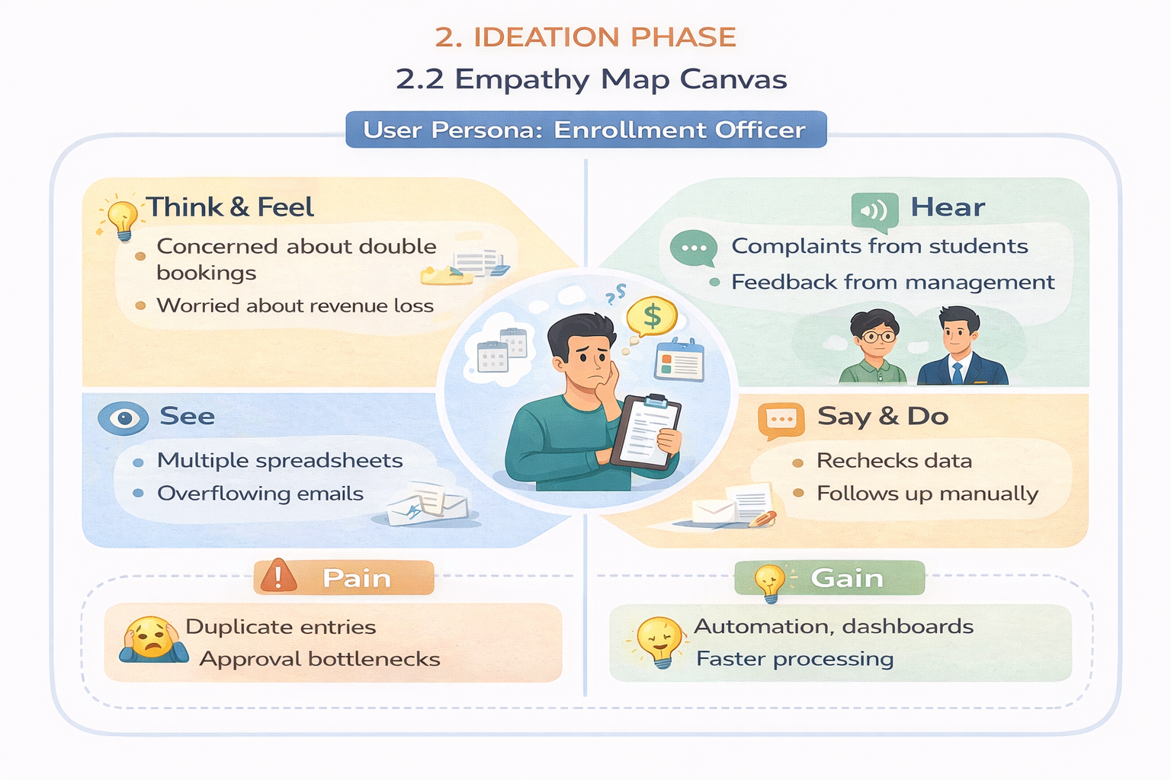

2.3 Brainstorming & Idea Prioritization
Step 1 – Brainstormed Ideas
- Spreadsheet automation
- Standalone enrollment portal
- ERP integration
- Salesforce-based enrollment system
Step 2 – Grouping
- Manual solutions
- Semi-automated solutions
- Fully automated cloud solutions
Step 3 – Prioritization
Salesforce-based SECMS was selected due to high feasibility and high impact.

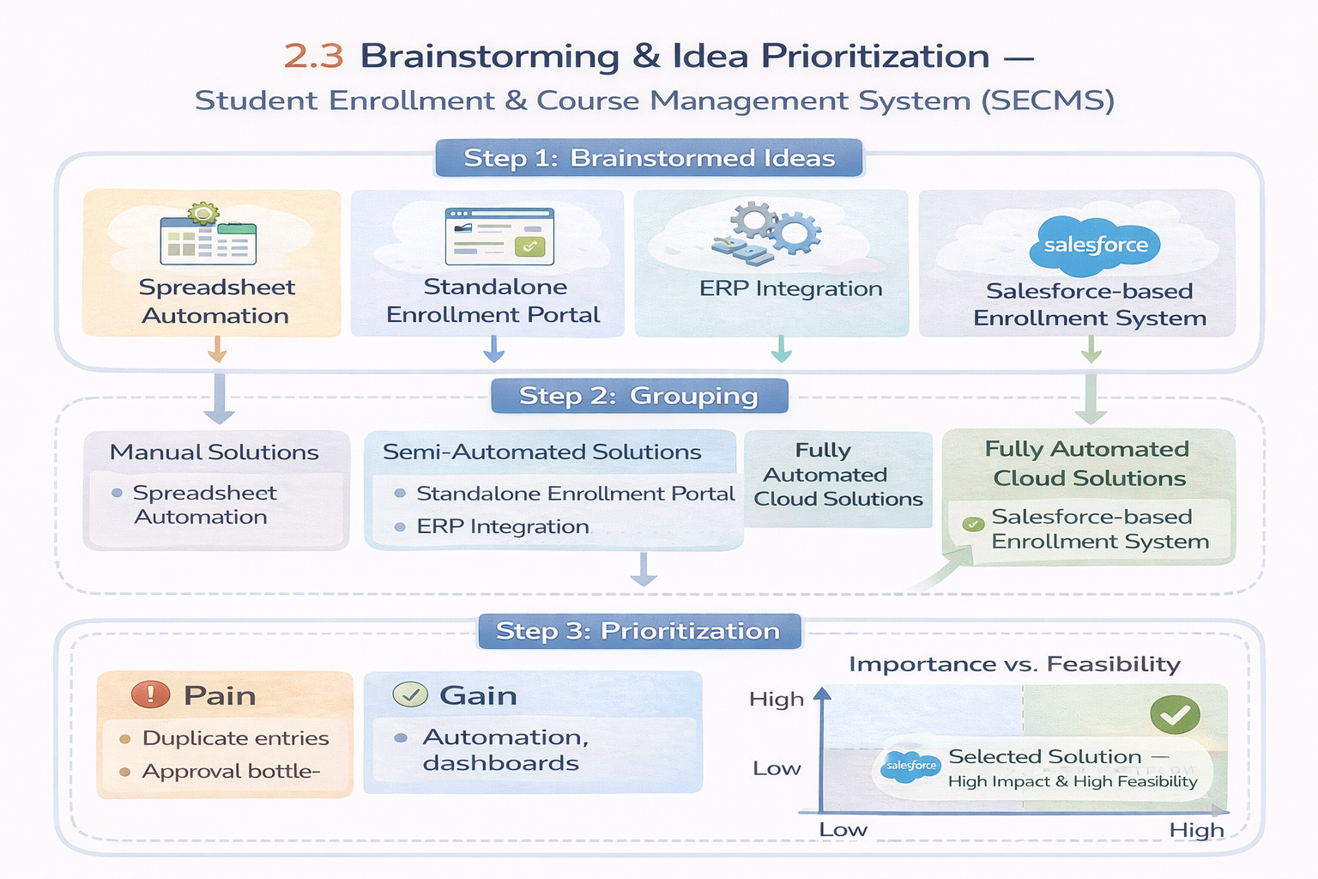

3.REQUIREMENT ANALYSIS PHASE

3.1 Customer Journey Map
Stages covered:
- Awareness & Registration
- Course Selection
- Enrollment Request
- Fee Payment
- Approval
- Instructor Assignment
- Reporting & Completion

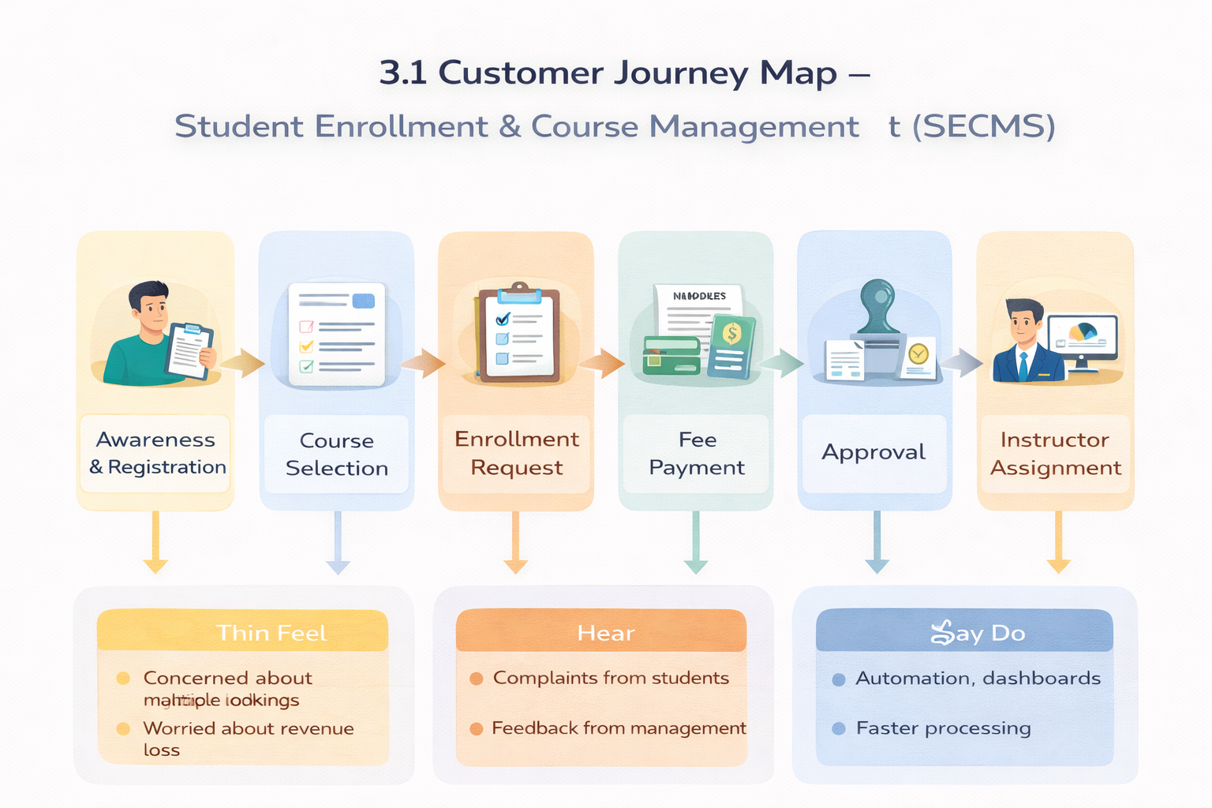

3.2 Solution Requirements
Functional Requirements

FR No | Epic | Description
FR-1 | Student Management | Manage student records
FR-2 | Course Management | Create and manage courses
FR-3 | Enrollment Processing | Request, approve, reject enrollments
FR-4 | Instructor Assignment | Auto-assign instructors
FR-5 | Reporting | Dashboards and reports

Non-Functional Requirements
NFR-1: Usability
The system shall provide a simple, intuitive, and user-friendly interface that enables enrollment officers, administrators, instructors, and students to perform operations efficiently with minimal training. Navigation shall be organized through clearly labeled tabs, dashboards, and forms to reduce user effort and errors.
Examples:
- Quick student registration form
- One-click enrollment approval
- Role-based dashboards
NFR-2: Security
The system shall ensure the confidentiality, integrity, and protection of student and institutional data through secure authentication, authorization, and access controls. Sensitive information such as personal data, enrollment history, and academic records shall only be accessible to authorized users.
Examples:
- Only admins can modify course details
- Instructors view only assigned students
- Students cannot access other student records
NFR-3: Reliability
The system shall operate consistently and accurately without failures during enrollment processing, approvals, and reporting. Automation logic shall execute correctly to avoid duplicate or incorrect enrollments.
Examples:
- No duplicate course registration
- Accurate status updates after approvals
- Consistent report generation
NFR-4: Performance
The system shall provide fast response times for all operations to ensure smooth and uninterrupted user experience, especially during peak admission periods.
Examples:
- Quick dashboard refresh
- Fast search for student records
- No lag during bulk uploads
NFR-5: Scalability
The system shall support future growth in the number of students, courses, departments, and users without degradation in performance or functionality. It shall allow easy addition of new modules and features.
Examples:
- Add new departments without redesign
- Handle increased admissions annually
- Extend to mobile or portal integration

NFR-6: Availability
The system shall be continuously accessible to users during institutional working hours and must minimize downtime. The platform shall support high availability for academic operations.
Examples:
- 24/7 cloud access
- Reliable during peak admission season
- Automatic backup of student records

3.3 Data Flow Diagram
- User inputs student and enrollment data
- System validates and stores records
- Approval process routes data
- Reports and dashboards consume processed data.
The system processes enrollment requests, validates data, routes approvals, assigns instructors, and generates reports.
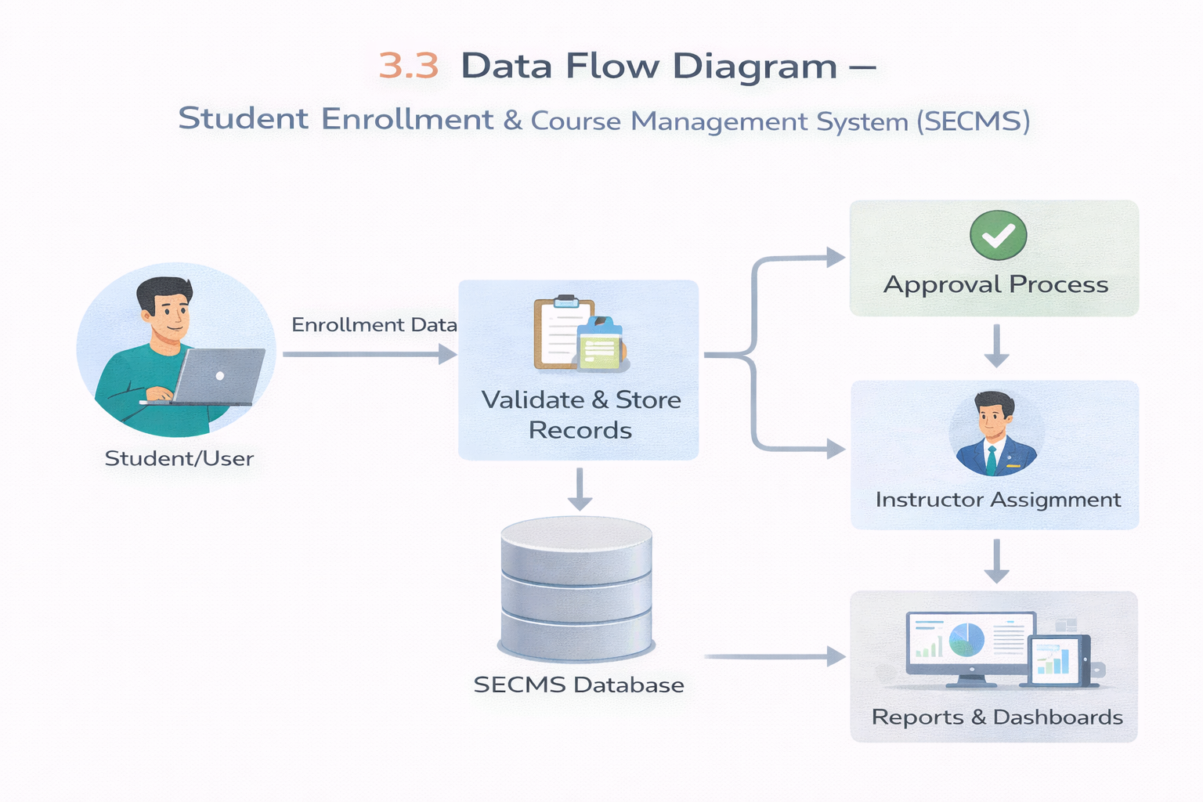

3.4 Technology Stack
Layer | Technology
UI | Salesforce Lightning
Logic | Salesforce Flows
Database | Salesforce Objects
Automation | Validation Rules, Approval Process
Reporting | Reports & Dashboards

4. PROJECT DESIGN PHASE

4.1 Problem–Solution Fit
SECMS directly addresses fragmented enrollment workflows by aligning user behavior, constraints, and automation using Salesforce-native capabilities.
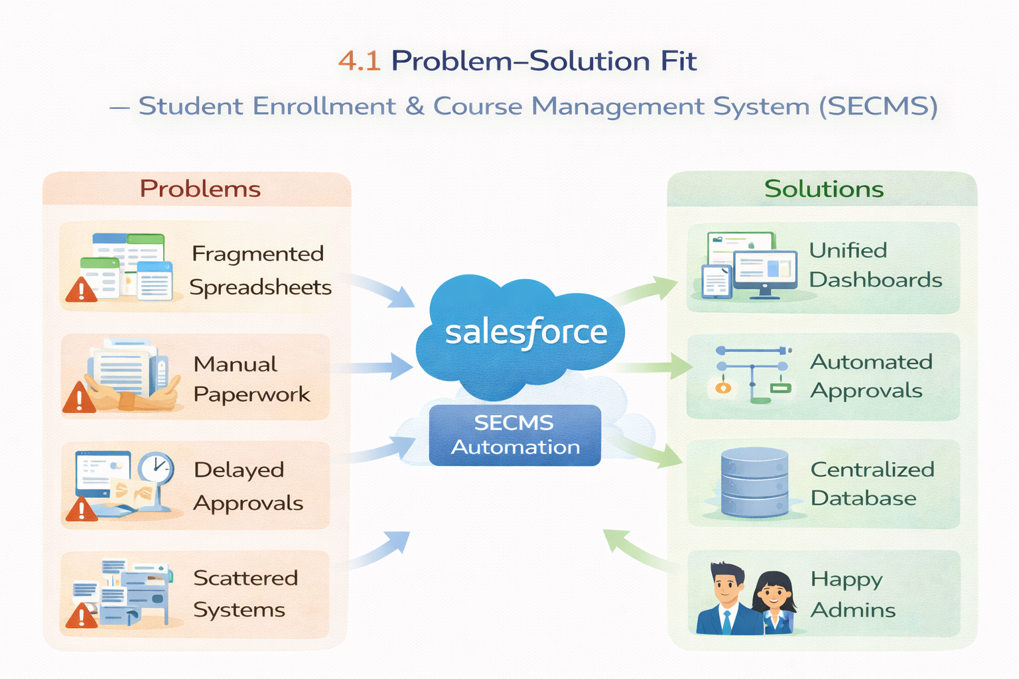

4.2 Proposed Solution
Functional Requirements

Parameter | Description
Problem | Manual enrollment handling
Solution | Salesforce-based SECMS
Novelty | End-to-end automation
Social Impact | Improved student experience
Revenue Model | Institutional deployment
Scalability | Multi-department support

4.3 Solution Architecture
The architecture integrates Salesforce objects, automation flows, approval processes, dashboards, and security layers.

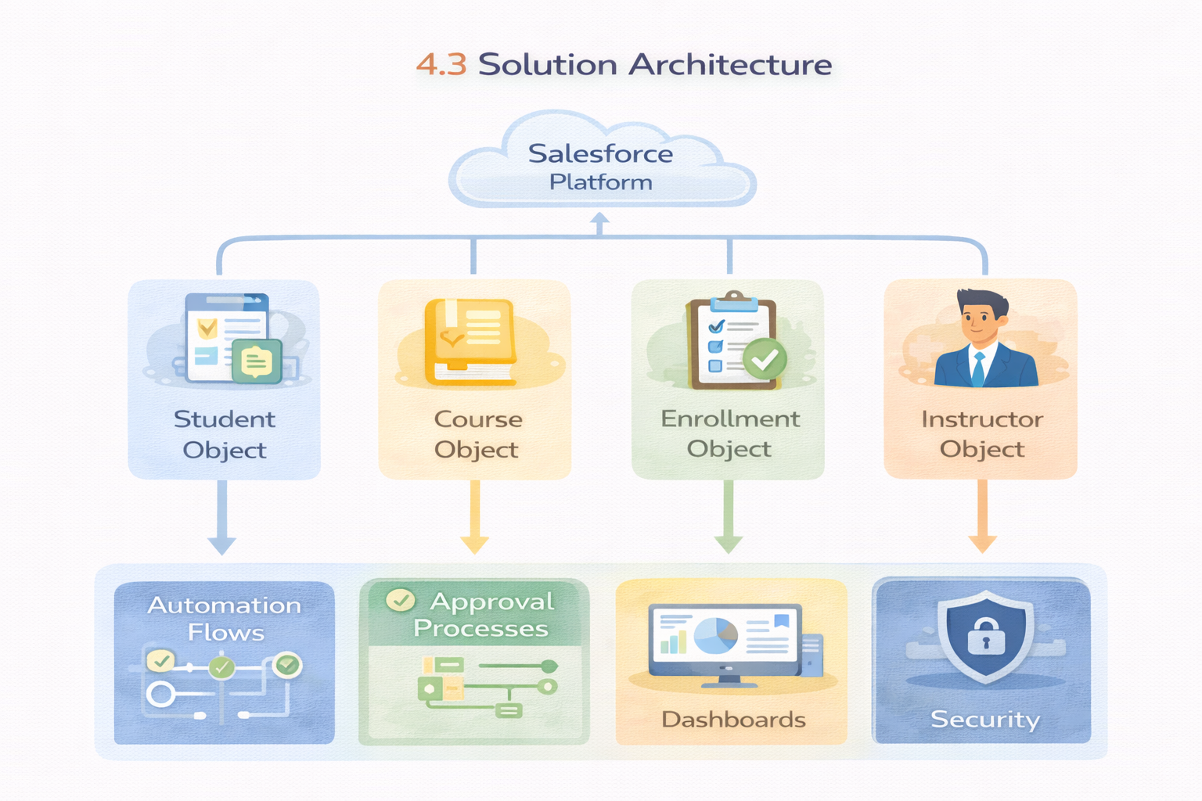

5. PROJECT PLANNING & SCHEDULING

5.1 Project Planning
- Agile methodology
- Epics → Stories → Story Points
- Sprint-based execution
- Velocity calculation used for estimation
Product Backlog, Sprint Schedule, and Estimation (4 Marks)
Use the below template to create product backlog and sprint schedule
Sprint | Functional Requirement (Epic) | User Story Number | User Story / Task | Story Points | Priority | Team Members
Sprint-1 | Developer Setup | USN-1 | As a system administrator, I want to create a Salesforce developer account so that I can configure and deploy the Student Enrollment system.. | 1 | High | Member1
Sprint-1 | Data Modeling | USN-2 | As an admin, I want to create custom objects for Student, Course, Enrollment, and Instructor so that academic data can be stored and managed efficiently. | 3 | High | Member2
Sprint-2 | Data Modeling | USN-3 | As a user, I want dedicated tabs for each object so that I can easily navigate between students, courses, enrollments, and instructors. | 3 | High | Member3
Sprint-2 | Data Modeling | USN-4 | As an admin, I want to create relevant fields such as student details, course information, and enrollment status so that complete records can be captured accurately. | 5 | High | Member4
Sprint-2 | Data Modeling | USN-5 | As an enrollment officer, I want a centralized Lightning App so that I can access all academic operations from one interface. | 3 | High | Member4
Sprint-2 | Data Modeling | USN-6 | As an admin, I want to define relationships between students, courses, and enrollments so that the system can logically link and track academic activities. | 5 | Medium | Member1
Sprint-2 | Data Modeling | USN-7 | As a user, I want customized page layouts so that only relevant information is displayed, improving clarity and ease of data entry. | 5 | High | Member2
Sprint-3 | Automation | USN-8 | As a system, I want to validate input data such as mandatory fields and enrollment limits so that incorrect or incomplete records are prevented. | 3 | High | Member4
Sprint-3 | Automation | USN-9 | As a system, I want automated flows to handle enrollment processing and notifications so that manual effort is reduced and processes become faster. | 3 | High | Member4
Sprint-3 | Automation | USN-10 | As an administrator, I want an approval process for enrollment requests so that registrations are verified before confirmation. | 5 | High | Member1
Sprint-4 | Security | USN-11 | As an admin, I want to configure role-based security so that users can only access data relevant to their responsibilities. | 5 | High | Member2
Sprint-5 | Reports | USN-12 | As a manager, I want reports on student enrollments, course registrations, and instructor assignments so that I can monitor academic operations. | 4 | High | Member3
Sprint-6 | Dashboards | USN-13 | As a manager, I want visual dashboards showing enrollment statistics and trends so that I can quickly analyze system performance. | 4 | Medium | Member4

Project Tracker, Velocity & Burndown Chart: (4 Marks)
Sprint | Total Story Points | Duration | Sprint Start Date | Sprint End Date (Planned) | Story Points Completed (as on Planned End Date) | Sprint Release Date (Actual)
Sprint-1 | 20 | 6 Days | 24 Oct 2022 | 29 Oct 2022 | 20 | 29 Oct 2022
Sprint-2 | 20 | 6 Days | 31 Oct 2022 | 05 Nov 2022
Sprint-3 | 20 | 6 Days | 07 Nov 2022 | 12 Nov 2022
Sprint-4 | 20 | 6 Days | 14 Nov 2022 | 19 Nov 2022

6. Project Development Phase:

Project Flow:

Milestone 1: Salesforce Developer Account Creation
Milestone 2: Custom Object Creation (Student, Course, Enrollment, Instructor)
Milestone 3: Tabs Creation
Milestone 4: Lightning App Creation
Milestone 5: Fields Creation
Milestone 6: Create Relationships
Milestone 7: Page Layout Customization
Milestone 8: Validation Rules
Milestone 9: Flows (Automation)
Milestone 10: Approval Process
Milestone 11: Reports
Milestone 12: Dashboards
Milestone 13: Security Setup
Milestone 14: Conclusion

What you'll learn
- Real-time Salesforce project implementation
- Designing custom objects and relationships
- Creating page layouts & record types
- Writing validation rules
- Building automation with flows
- Creating approval workflows
- Developing reports & dashboards
- Setting up security with profiles, permission sets, and sharing
- End-to-end application testing

Milestone 1-Salesforce :
Introduction:

Are you new to Salesforce? Not sure exactly what it is, or how to use it? Don’t know where you should start on your learning journey? If you’ve answered yes to any of these questions, then you’re in the right place. This module is for you.
Welcome to Salesforce! Salesforce is game-changing technology, with a host of productivity-boosting features, that will help you sell smarter and faster. As you work toward your badge for this module, we’ll take you through these features and answer the question, “What is Salesforce, anyway?”.

What Is Salesforce?

Salesforce is your customer success platform, designed to help you sell, service, market, analyze, and connect with your customers.
Salesforce has everything you need to run your business from anywhere. Using standard products and features, you can manage relationships with prospects and customers, collaborate and engage with employees and partners, and store your data securely in the cloud. So what does that really mean? Well, before Salesforce, your contacts, emails, follow-up tasks, and prospective deals might have been organized something like this:
https://youtu.be/r9EX3lGde5k

Activity 1: Creating Developer Account:
Creating a developer org in salesforce.
Go to https://developer.salesforce.com/signup
On the sign up form, enter the following details :
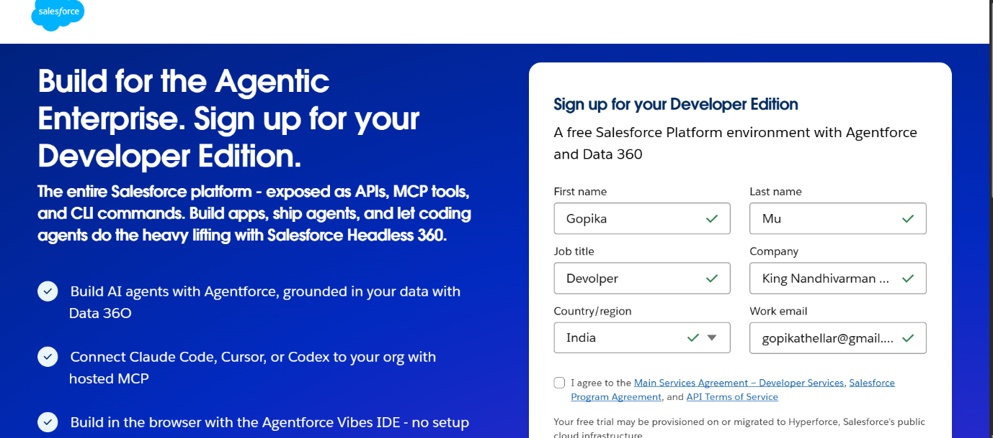
First name & Last name
Email
Role : Developer
Company : College Name
County : India
Postal Code : pin code
Username : should be a combination of your name and company
This need not be an actual email id, you can give anything in the format : username@organization.com
Click on sign me up after filling these.

Activity 2: Account Activation:

1. Go to the inbox of the email that you used while signing up. Click on the verify account to activate your account. The email may take 5-10mins.

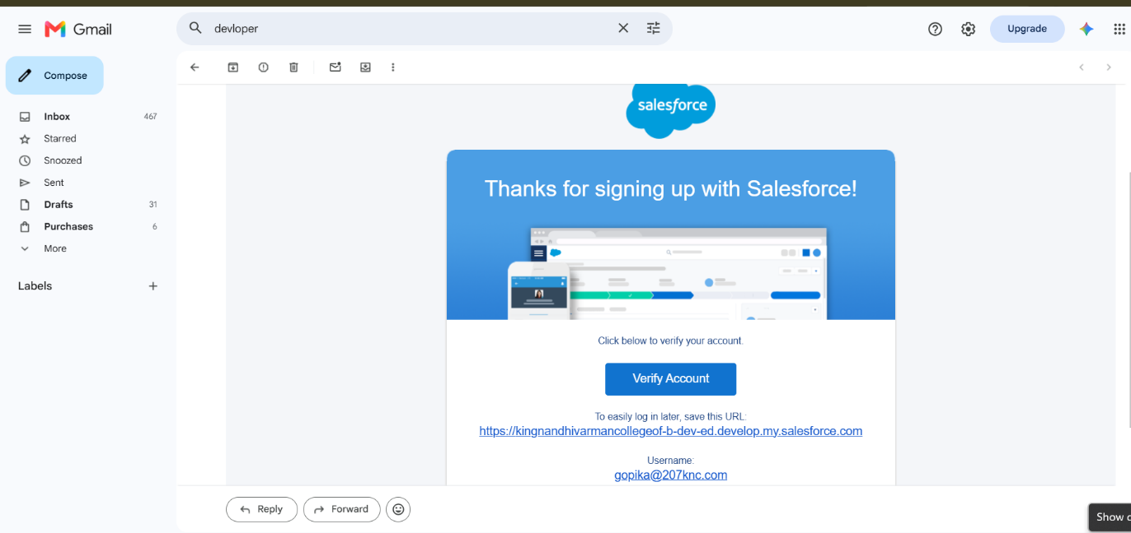

2. Click on Verify Account
3. Give a password and answer a security question and click on change password.
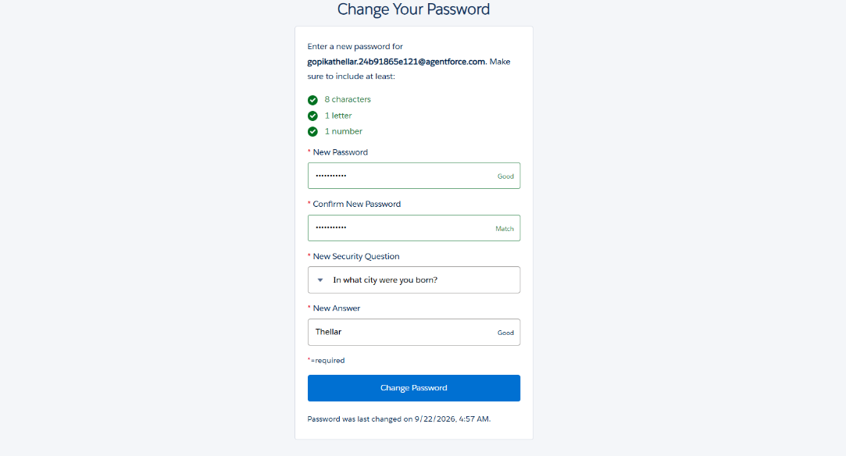

4. Then you will redirect to your salesforce setup page.
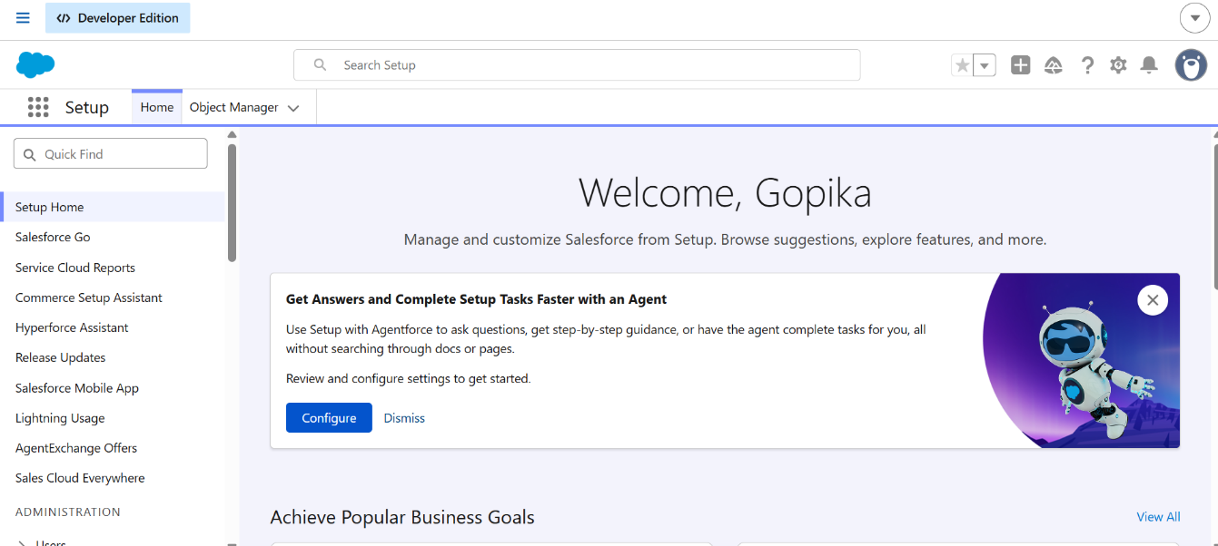

Milestone 2 – Objects:

Activity 1: Creating Student Object:
The purpose of creating the Student custom object is to store and manage information about students such as their personal details, contact information, and enrollment status.
To create the Student object:

Go to the Setup page.

Click on Object Manager.

Click on Create → Custom Object.

Enter the details as below:
- Label: Student
- Plural Label: Students
- Object Name: Student
- Record Name: Student Name
- Data Type: Text
- Under Optional Features, select:
- Allow Reports
- Allow Activities (optional but recommended)
- Track Field History (optional, if you want)
- Under Search Status, select:
- Allow Search
- Click Save.
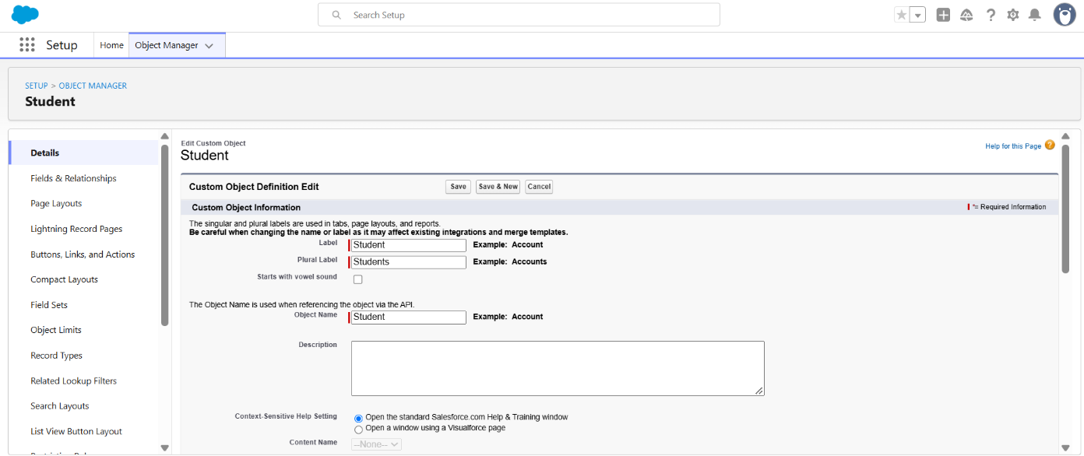

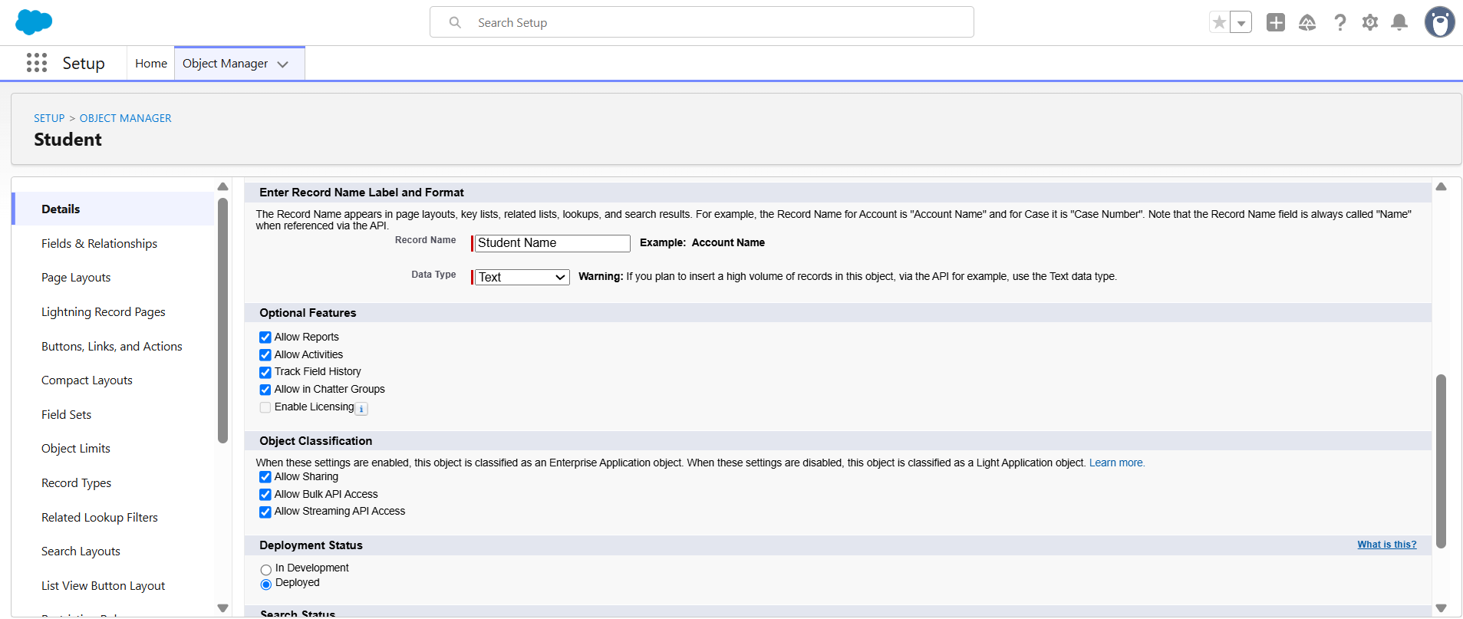

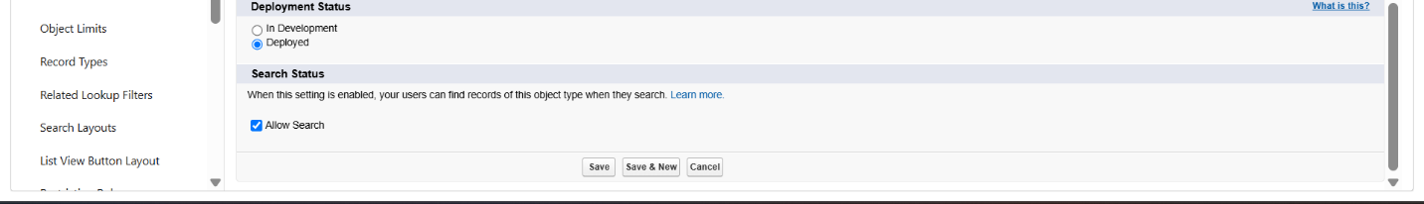

In the same way Create Courses, Instructors, and Enrolments objects

Milestone 3 - Fields:

Table 1: Student Object Fields:

Field Label | Data Type
Student Name | Text (Standard)
Email | Email
Phone | Phone
Date of Birth | Date
Student Status | Picklist
Address | Text Area

Table 2: Course Object Fields:

Field Label | Data Type
Course Name | Text (Standard)
Category | Picklist
Duration | Number/Text
Course Fee | Currency
Description | Text Area

Table 3: Instructor Object Fields:

Field Label | Data Type
Instructor Name | Text (Standard)
Instructor Code | Text
Expertise | Picklist
Phone | Phone
Email | Email

Table 4: Enrollment Object Fields:

Field Label | Data Type
Student | Lookup (Student)
Course | Lookup (Course)
Instructor | Lookup (Instructor)
Enrollment Date | Date
Enrollment Status | Picklist
Fees Paid | Checkbox
Total Amount | Currency
Comments | Text Area

Milestone 4 – Create Relationships:

Activity 1: Create Lookup from Enrollment to Student:
- Go to Setup → click Object Manager.
- Type Enrollment in Quick Find → click Enrollment__c object.
- Click Fields & Relationships → click New.
- Select Lookup Relationship → click Next.
- For Related To, select Student__c → click Next.
- Enter Field Label: Student (API Name: Student__c).
- Click Next through Field-Level Security and Layout options (ensure it’s visible and added to layout).
- Click Save.
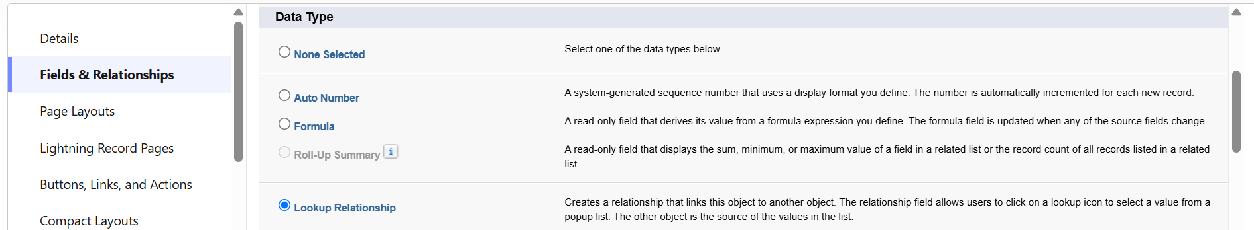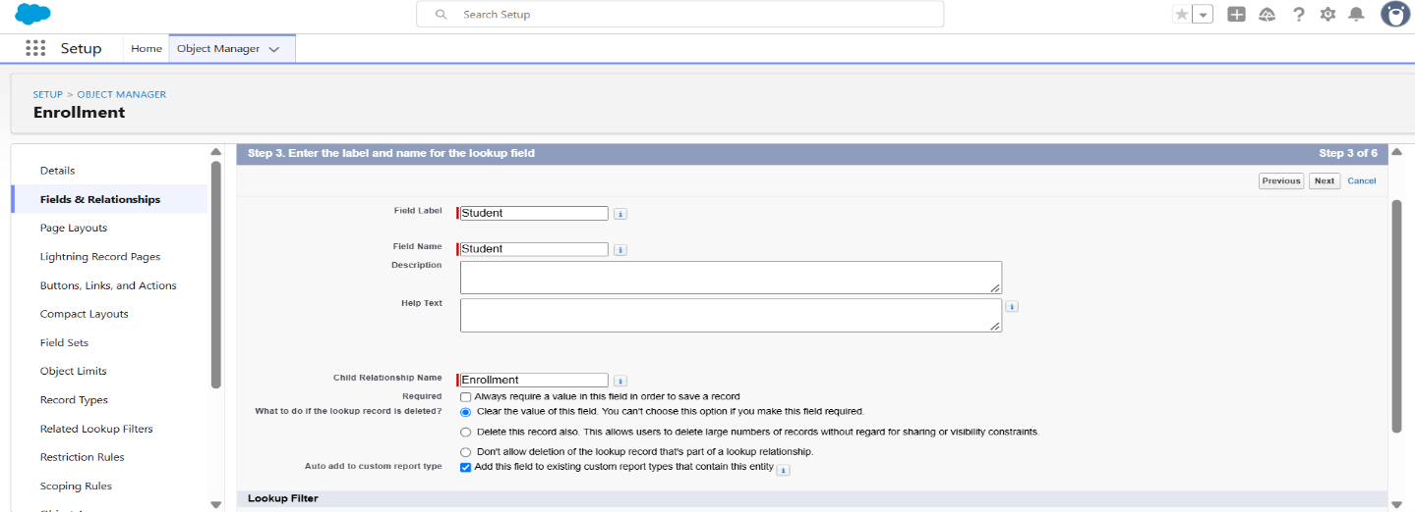

Activity 2: Create Lookup from Enrollment to Course
Purpose:
To link each Enrollment to a Course.

Steps:
- Go to Setup → Object Manager → Enrollment__c.
- Click Fields & Relationships → New.
- Select Lookup Relationship → Next.
- Related To: select Course__c → click Next.
- Field Label: Course (API Name: Course__c).
- Click Next (set visibility and layout) → Save.
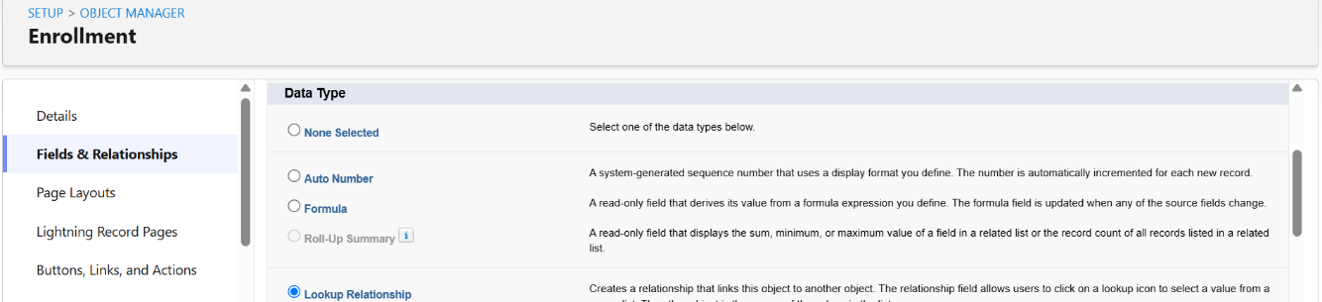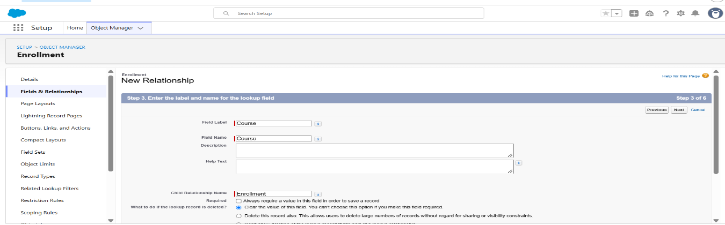

Activity 3: Create Lookup from Enrollment to Instructor:
Purpose:
To store which Instructor is assigned to a particular Enrollment.

Steps:
- Go to Setup → Object Manager → Enrollment__c.
- Click Fields & Relationships → New.
- Choose Lookup Relationship → Next.
- Related To: select Instructor__c → Next.
- Field Label: Instructor (API Name: Instructor__c).
- Complete Field-Level Security and Page Layout options → Save

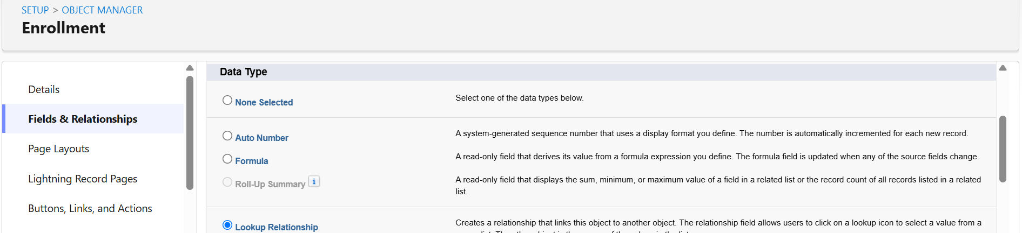
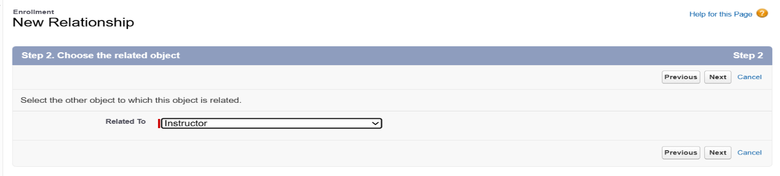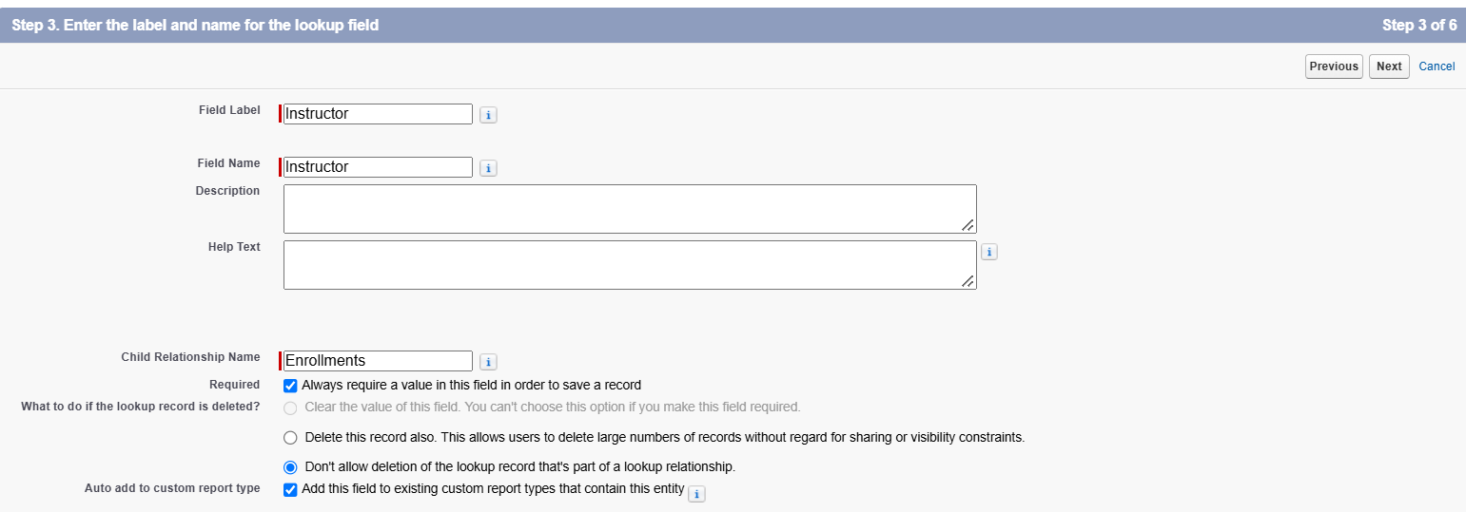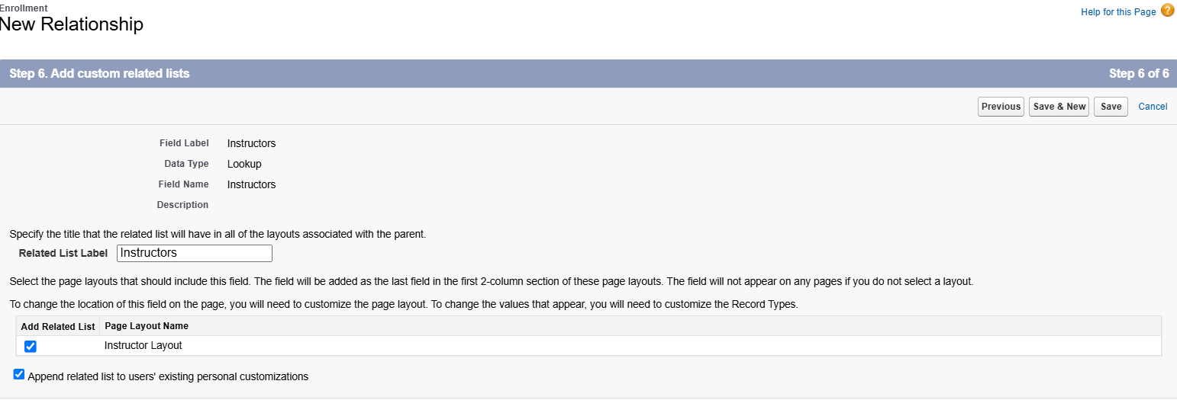

Milestone 5 – Validation Rules:

Activity 1: Student Email Domain Validation
Purpose:
To ensure students use only allowed institutional email addresses.

Steps:

Go to Setup → Object Manager → Student__c.
Click Validation Rules → New.
Rule Name: Student_Email_Domain_Validation.
Error Condition Formula: (example for @student.edu)
- NOT(CONTAINS(Email__c, "@student.edu"))

Error Message: Email must be a valid student institutional email.
Error Location: Field → Email__c.
Click Save.
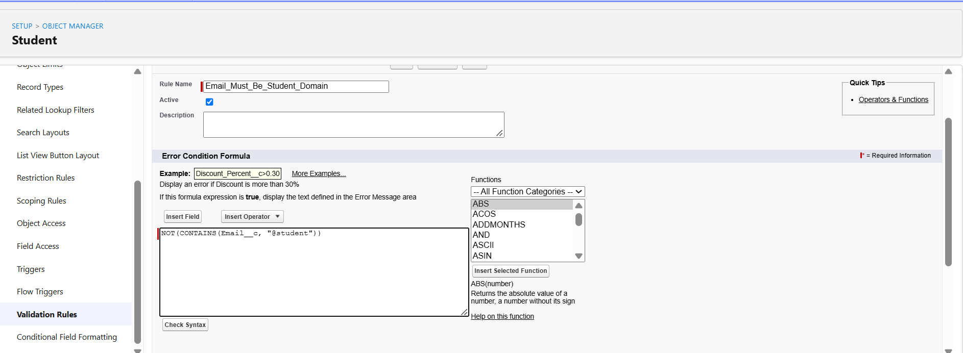
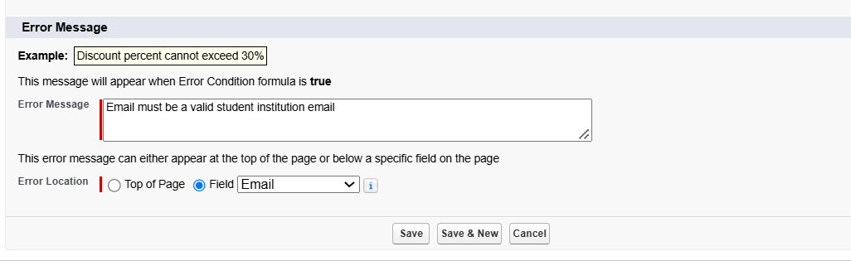

Activity 2: Fees Must Be Paid Before Approval

Purpose:
Prevent Enrollment from being approved until fees are paid.

Steps:

- Go to Setup → Object Manager → Enrollment__c.
- Click Validation Rules → New.
- Rule Name: Fees_Must_Be_Paid_Before_Approval.
- Error Condition Formula:
AND(
ISPICKVAL(Enrollment_Status__c, "Approved"),
Fees_Paid__c = FALSE
)
5.Error Message: Fees must be paid before approving an enrollment.
6.Error Location: Top of Page (or field as needed).
Click Save.
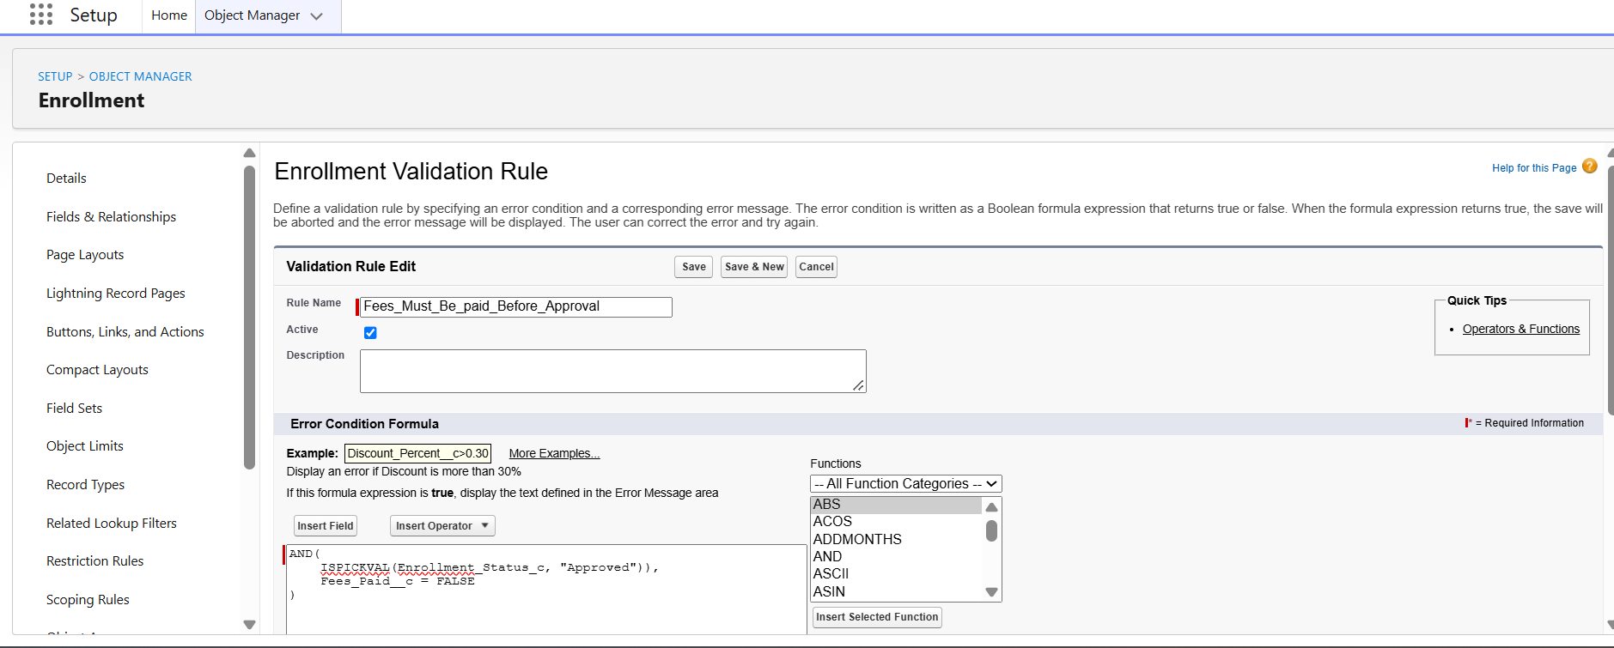
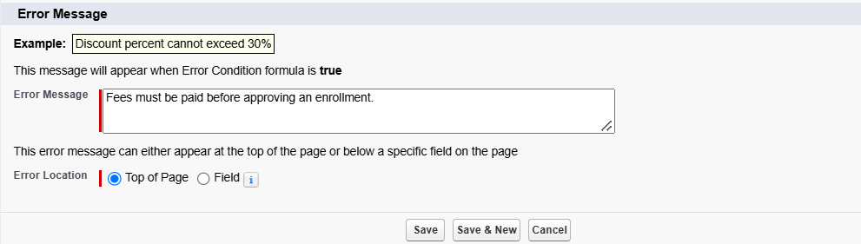

Milestone 6 – Approval Process

Activity 1: Create Approval Process for Enrollment Requests

Purpose:
Route Enrollment requests to the Training Manager for approval or rejection.

Steps:

- Go to Setup → Approval Processes → select Enrollment__c.
- Click Create New Approval Process → Use Standard Setup.
- Process Name: Approval_Enrollment_Request.
- Entry Criteria: Enrollment_Status__c = "Requested".
- Save and configure steps.
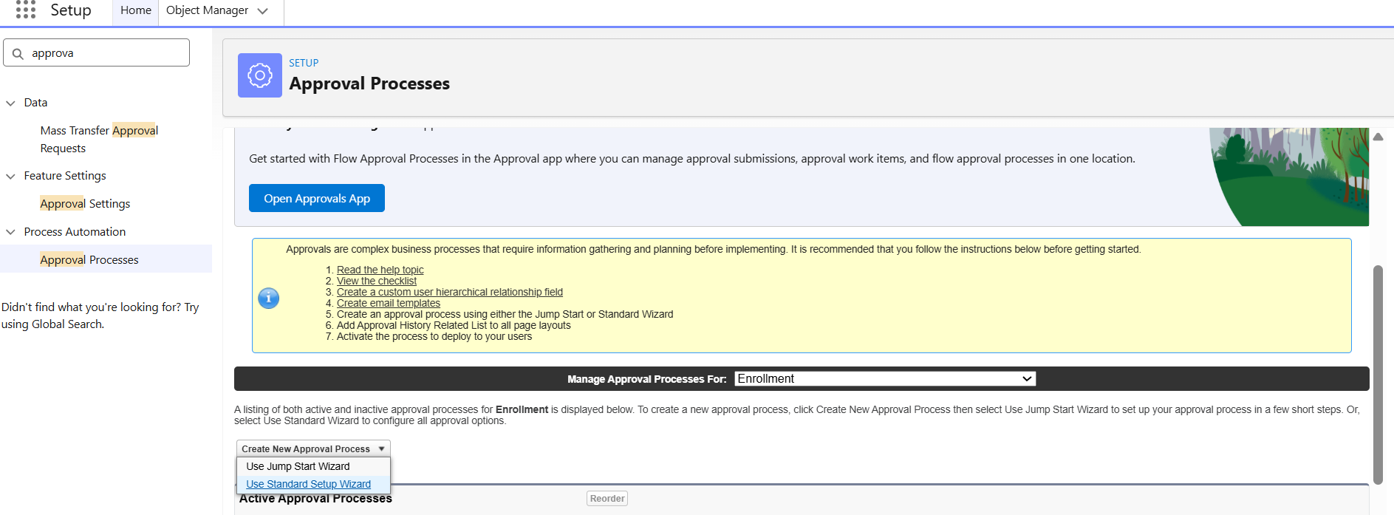
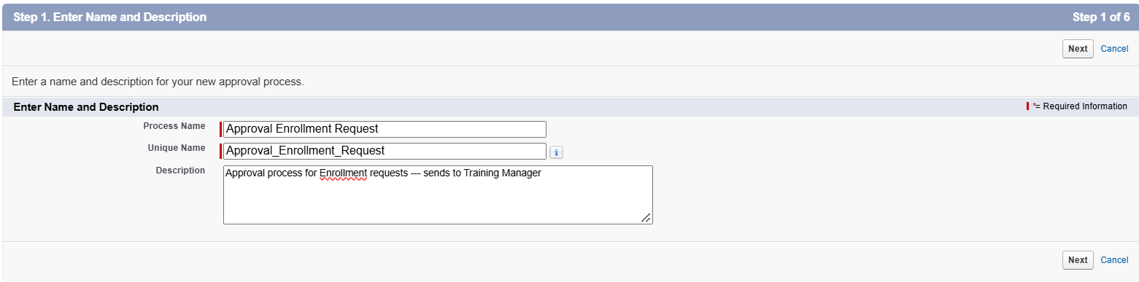
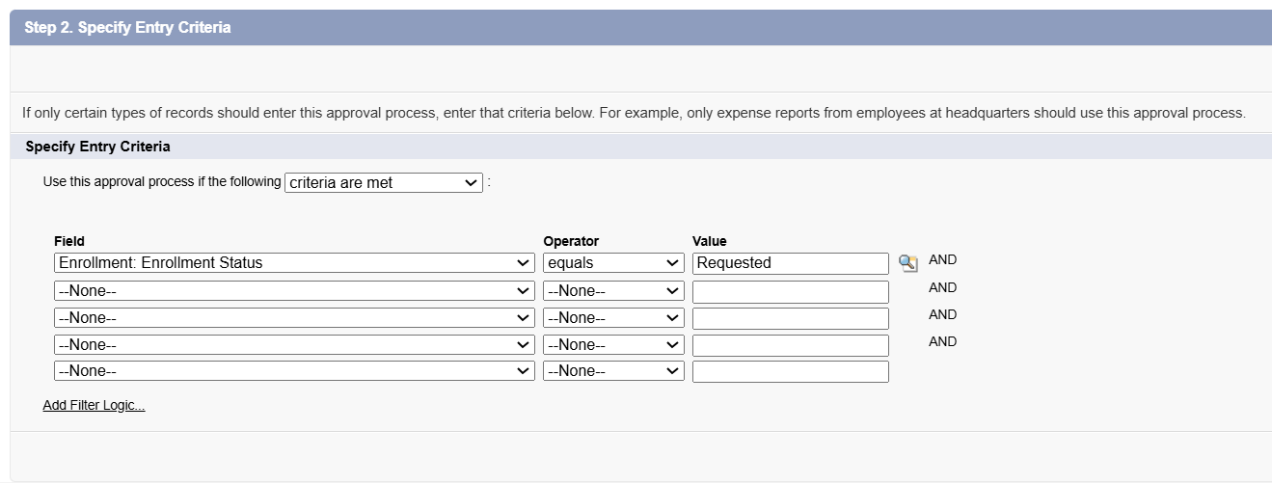
- Add Approval Step:
- Approver: specific Training Manager user.
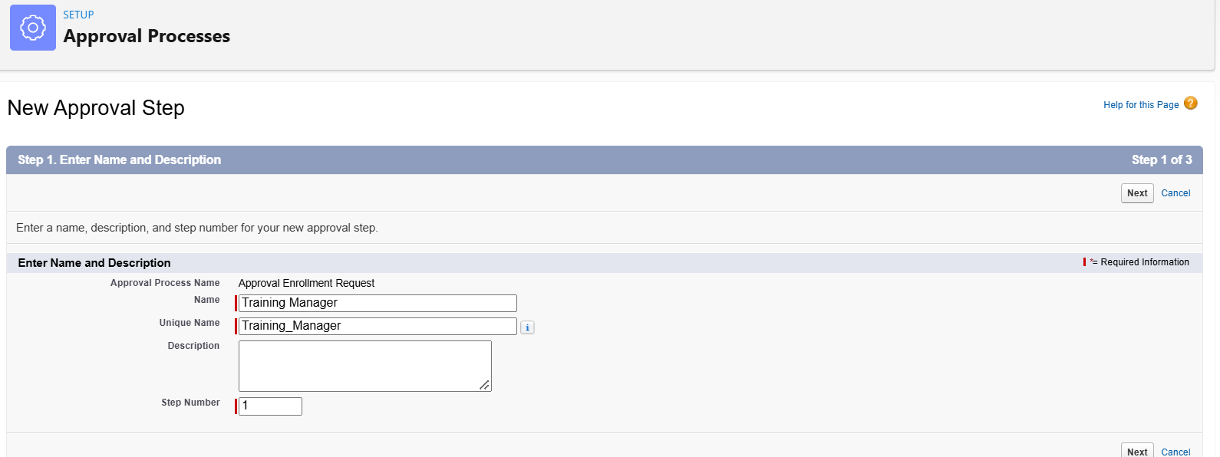
- Under Final Approval Actions:
- Add Field Update to set Enrollment_Status__c = "Approved".
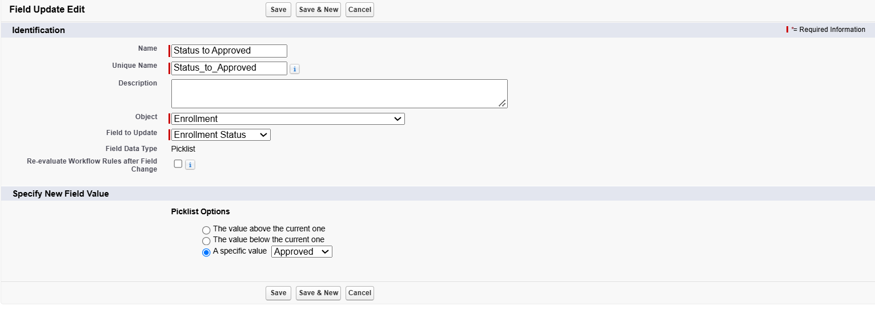
- Under Final Rejection Actions:
- Add Field Update to set Enrollment_Status__c = "Rejected".
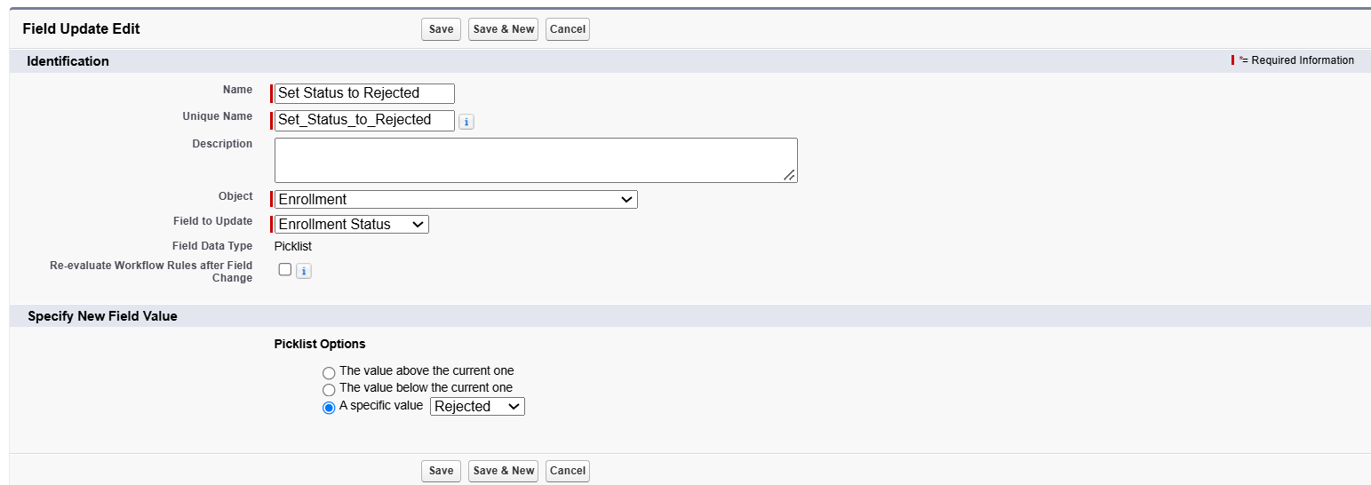
- Add Email Alert to send rejection email to student.
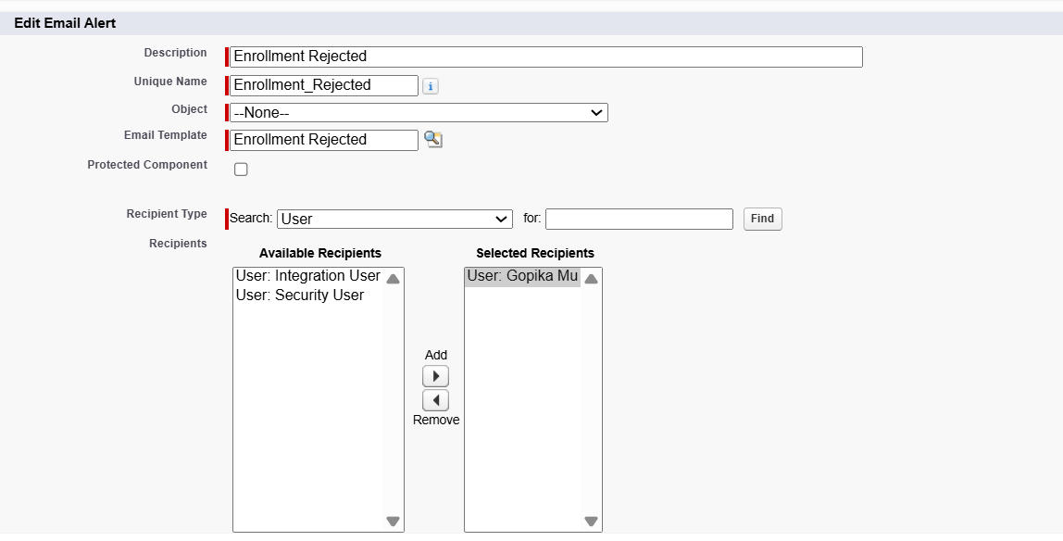
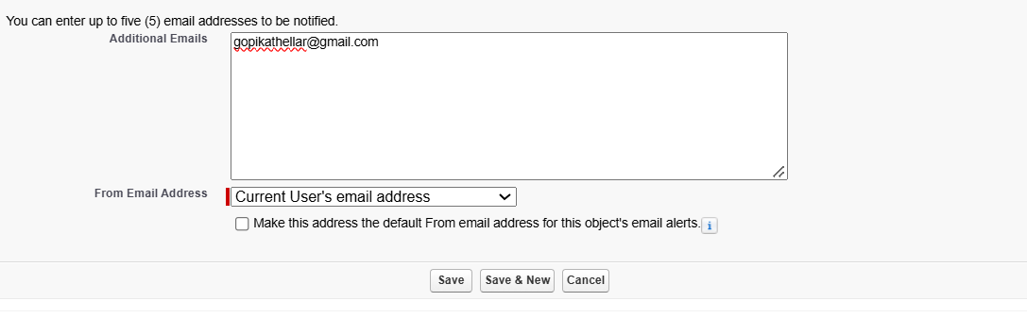
- Activate the approval process.

Milestone 7- Tabs

Activity 1: Creating a Tab for the Student Object:
Go to Setup.
- In the Quick Find box, type Tabs.
- Under Custom Object Tabs, click New.
- Select Student from the object list.
- Choose a tab style (icon).
- Click Next, assign it to all profiles, and then click Save.

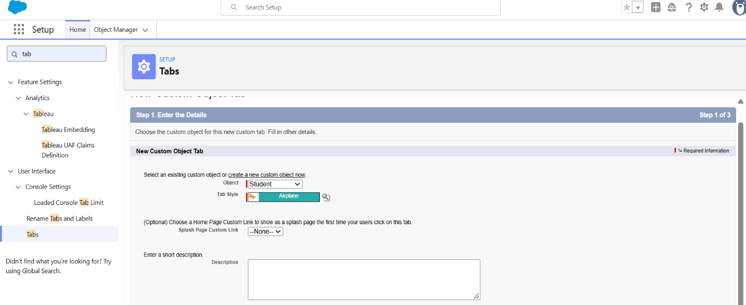

Activity 2: Creating Remaining Tabs

Now create the Tabs for the remaining Objects, they are “Courses, Instructors, Enrollment”.
Follow the same steps as mentioned in Activity -1

Milestone 8 - The Lightning App

Activity 1: Creating the Lightning Application for the Project
Navigate to Setup.

Enter App Manager in the Quick Find search box.
Click New Lightning App.
Provide the app details:
App Name: Student Enrollment & Course Management
Developer Name auto-fills
Description: Optional, but can describe the purpose of the app
Click Next and choose the following settings:
App Branding (optional): Add logo or select color theme
Navigation Style: Choose Standard Navigation
Click Next and assign the app to specific profiles (e.g., Admin, Enrollment Officer, Instructor).
Click Next to select the items (tabs) to be included in the app. Add:
- Student
- Course
- Instructor
- Enrollment
- Reports
- Dashboards
- Home
- Tasks
Click Next and review the app settings.
Finally, click Save & Finish.

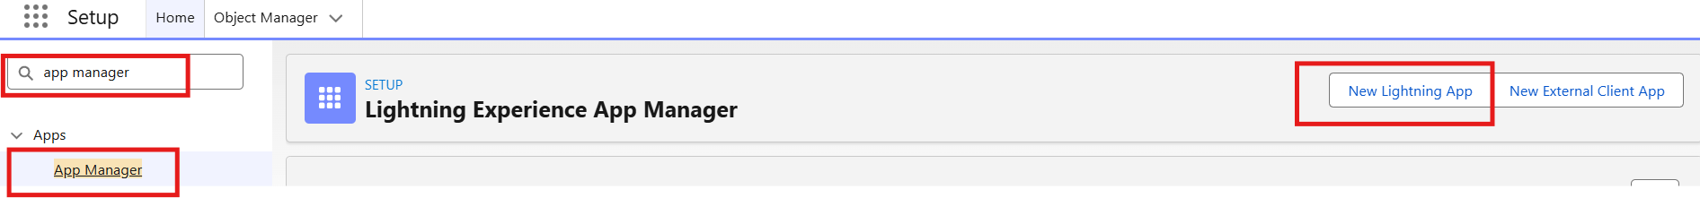
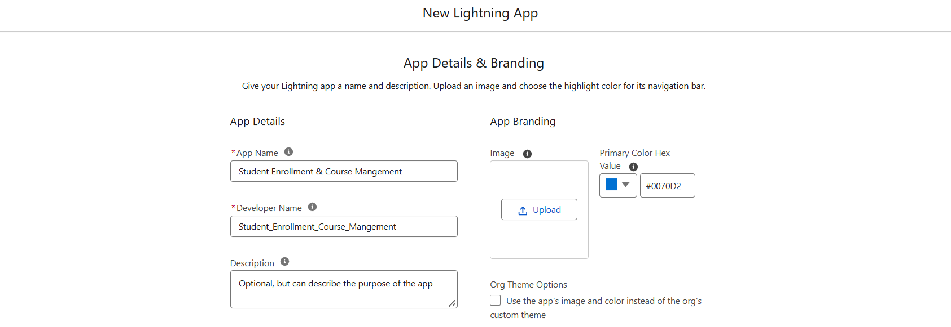
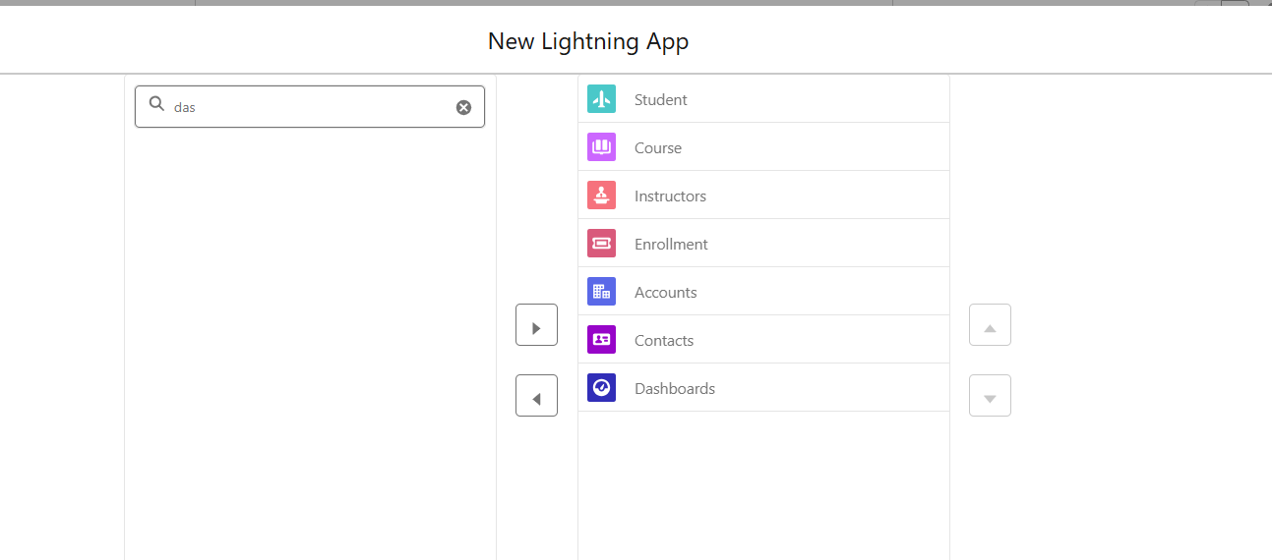
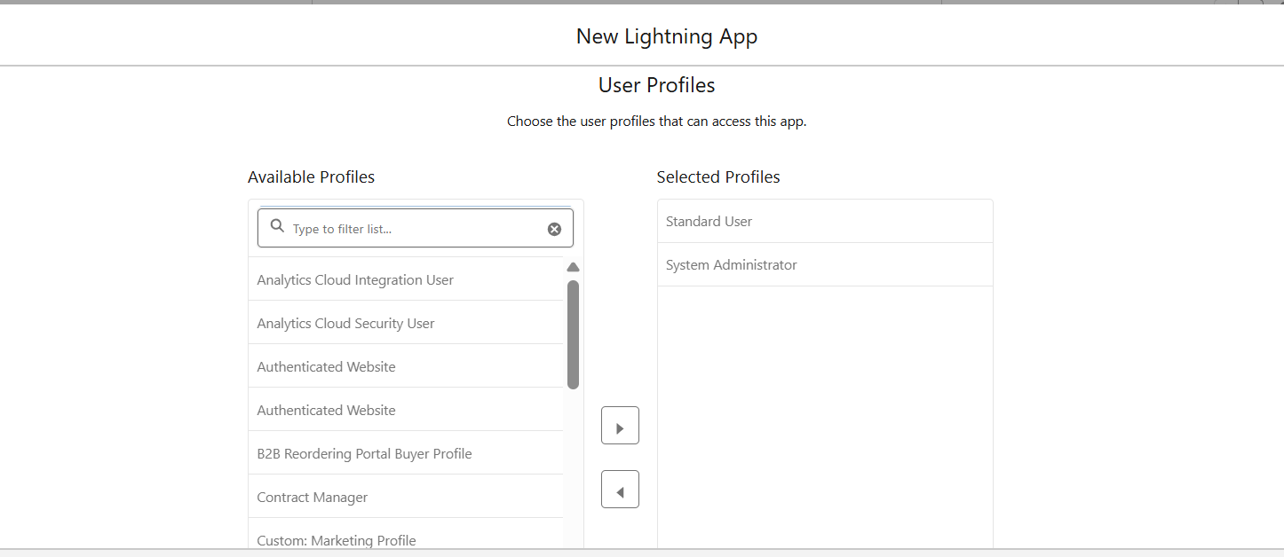

Milestone 9 – Page Layouts and Record:

Activity 1: Create Record Types for Enrollment:

Purpose:
To separate New Enrollment vs Re-Enrollment processes.
Steps:
1.Go to Setup → Object Manager → Enrollment__c.
2.Click Record Types → New.
3.For the first record type:
- Existing Record Type: Master
- Record Type Label: New Enrollment
- Enable for required profiles (Admin, Enrollment Officer).
- Select the default Page Layout → Save & New.
4.For the second record type:
- Record Type Label: Re-Enrollment
- Enable for the same profiles.
- Select the default Page Layout → Save.
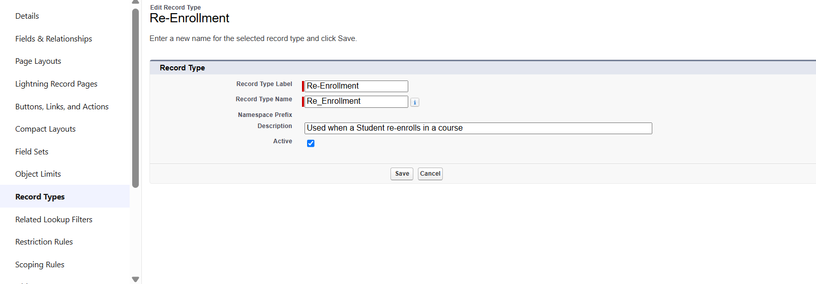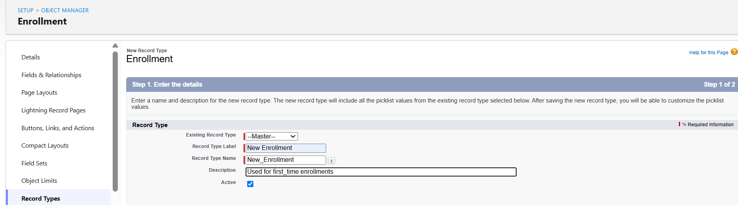

Activity 2: Separate Page Layout Creators for Each Enrollment Record Type

Purpose:
To show different fields for New Enrollment vs Re-Enrollment.

Steps:

1.Enrollment__c object → click Page Layouts.
2.Click New to create a layout for New Enrollment:
- Clone from existing Enrollment Layout → name it New Enrollment Layout → Save.
- Keep fields relevant for first-time enrollment: Student, Course, Instructor, Enrollment Date, Status, Fees, etc.
- Remove unnecessary re-enrollment fields if any.
- Click Save.
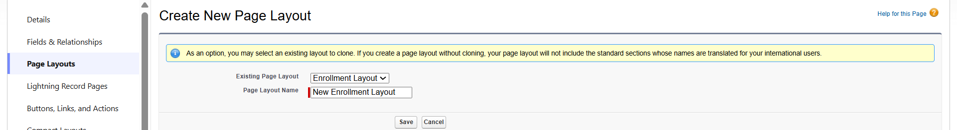
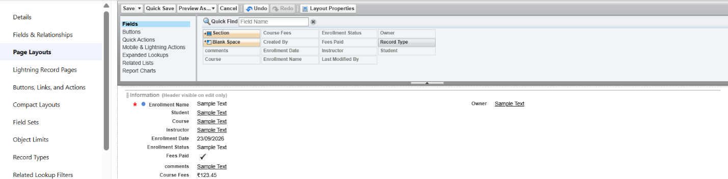
3.Again, click New to create Re-Enrollment Layout:
- Clone existing layout → name it Re-Enrollment Layout → Save.
- Include fields like previous Enrollment reference (if any), Re-Enrollment Reason, Status, Fees, etc.
- Click Save.
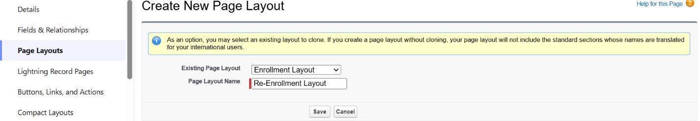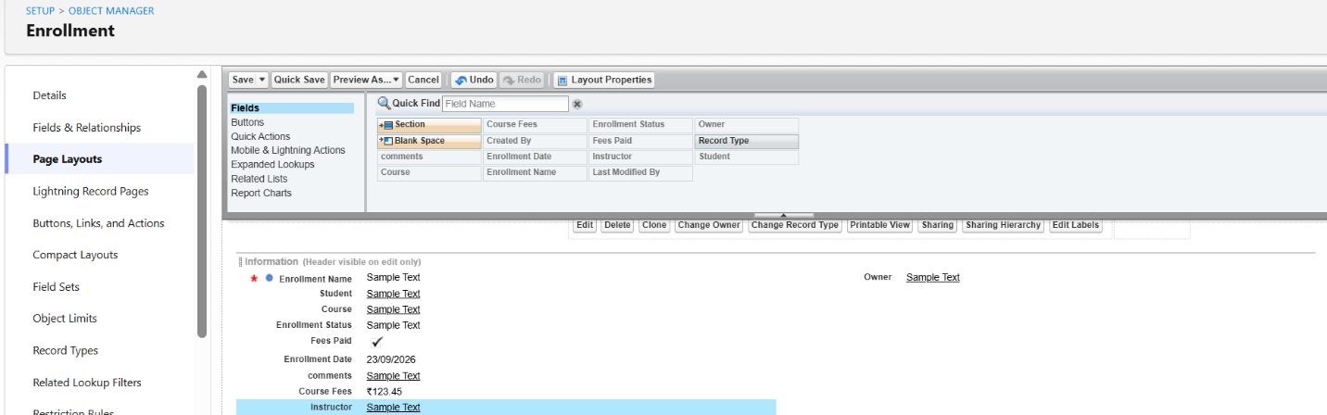

4.Click Page Layout Assignment → Edit Assignment.
5.For each profile and record type:

- New Enrollment → use New Enrollment Layout.
6.Re-Enrollment → use Re-Enrollment Layout.
Click Save.

Activity 3: Enrollment R Addelated Lists to Parent Objects:

Purpose:
To see all Enrollments from Student, Course, and Instructor records.
a) Student → Enrollment Related List
Go to Setup → Object Manager → Student__c.
Click Page Layouts → open the main layout.
In the palette, select Related Lists.
Drag Enrollments related list onto the layout.
Customize columns if needed → Save.
b) Course → Enrollment Related List
Go to Object Manager → Course__c → Page Layouts.
Open layout → add Enrollments related list.
Save.
c) Instructor → Enrollment Related List
Go to Object Manager → Instructor__c → Page Layouts.
Open layout → add Enrollments related list.
Save.

Milestone 10 – Automation with Flow

Activity 1: Auto-Populate Enrollment Date (Record-Triggered Flow)

Purpose:
Set Enrollment_Date__c to today when Enrollment is created.

Steps:

- Go to Setup → Flows → New Flow.
- Select Record-Triggered Flow → Create.
- Object: Enrollment__c.
- Trigger: A record is created.
- Optimize for Actions and Related Records → Done.
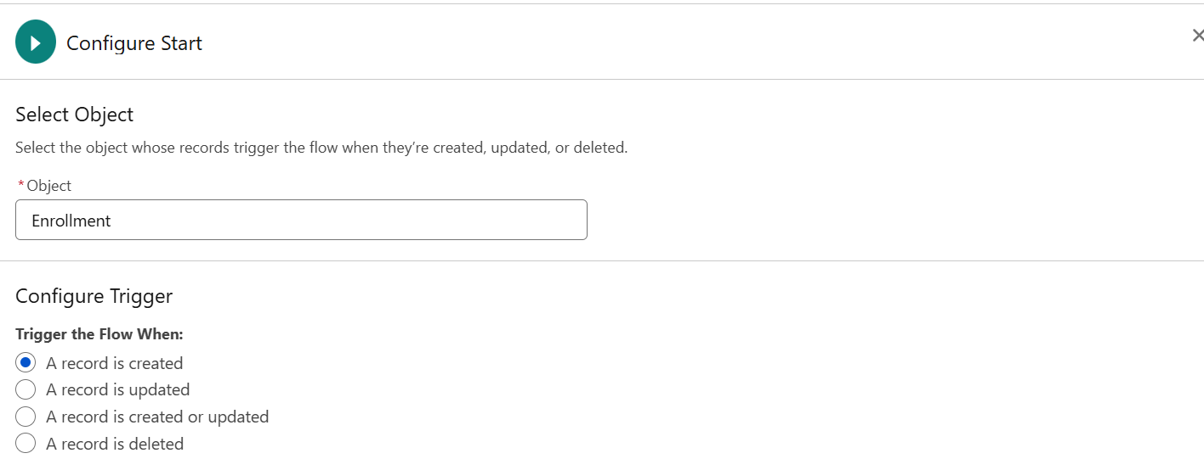
- Add Update Records element:
- Label: Set Enrollment Date.
- Use a record that triggered the flow.
- Field: Enrollment_Date__c → Value: $Flow.CurrentDate.
7.Save as SetEnrollmentDate → Activate.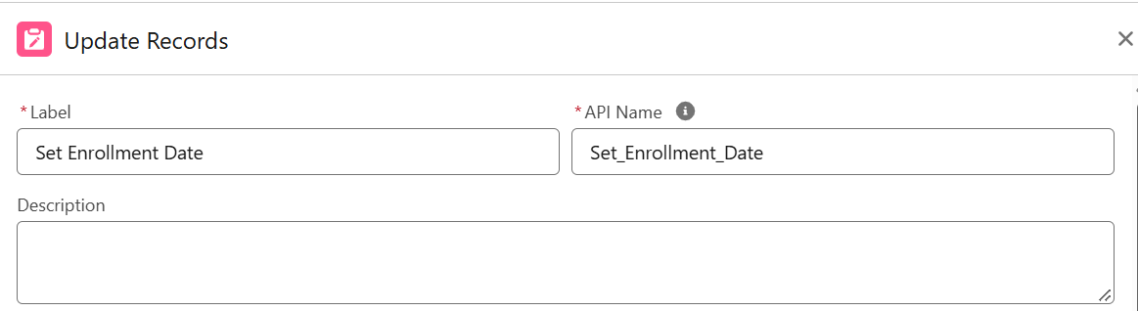

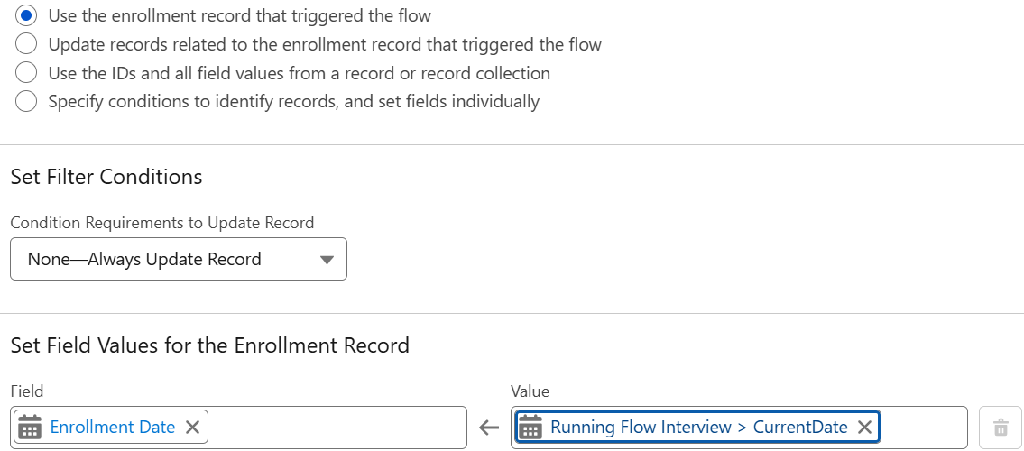

Activity 2: Send Email When Enrollment Approved

Purpose:
When Enrollment_Status__c = Approved, send email, alert admin, and set Student to Active.
Steps (high level for document):

- Create Email Template and Email Alert for student notification.

- Go to Flows → New → Record-Triggered Flow.
- Object: Enrollment__c, Trigger on update.
- Condition: Enrollment_Status__c Equals "Approved".
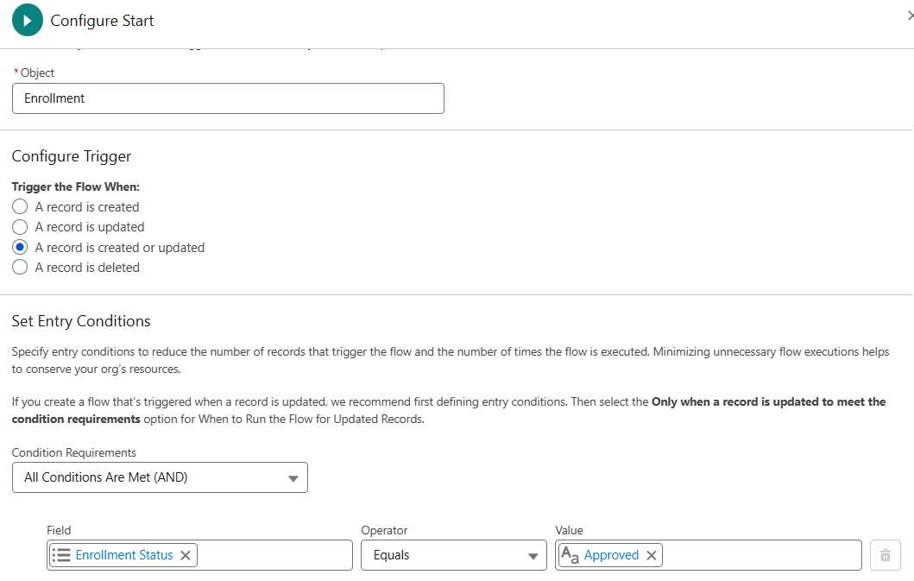
- Add Get Records to fetch related Student__c.
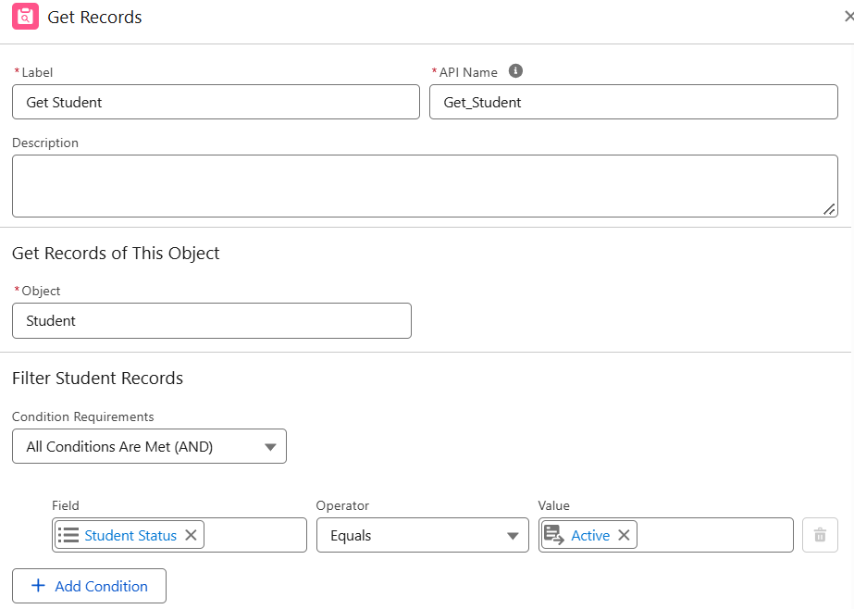
- Add Action (Email Alert) to send email to student.
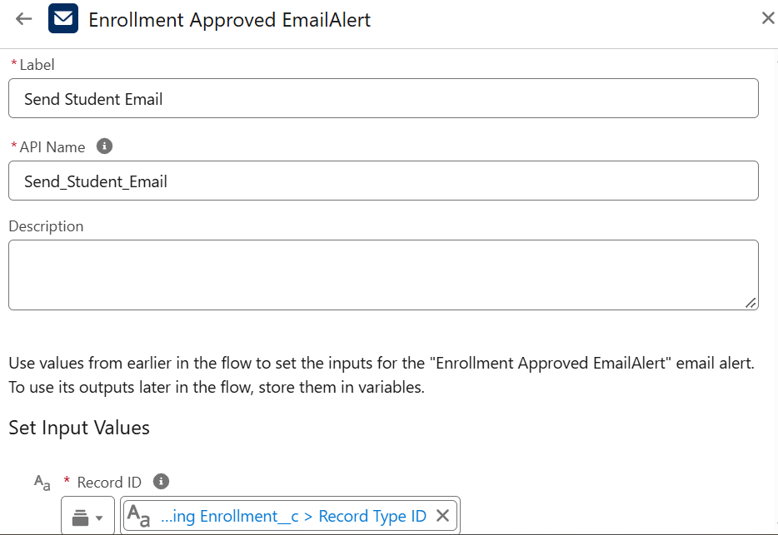
- Add Action to notify Admin if needed.
- Add Update Records to set Student__c.Status__c = "Active".
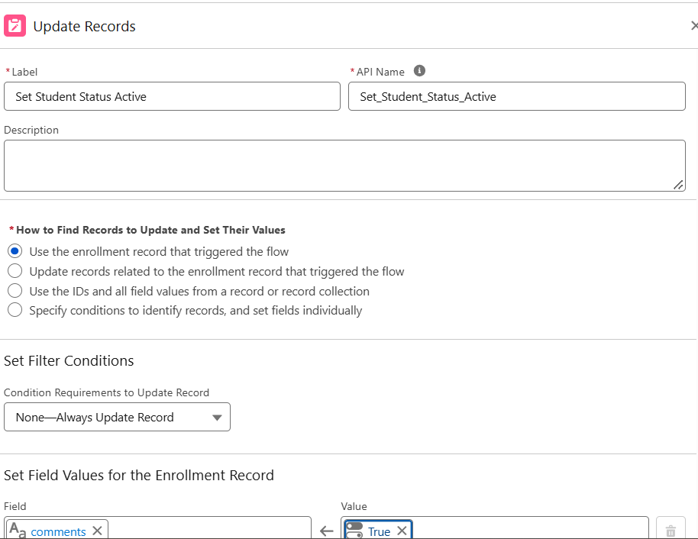
- Save as Enrollment Approved Action → Activate.

Activity 3: Auto-Assign Instructor Based on Course Category

Purpose:
Assign Instructor automatically based on Course category.

Rules:

Technical → Instructor A
Language → Instructor B
Non-Technical → Instructor C

Steps:

- Prepare Instructor__c records with codes (e.g., INSTR_A, INSTR_B, INSTR_C).
- Create Record-Triggered Flow on Enrollment__c (created/updated).
- Add Get Records to fetch related Course__c.
- Add Decision element on Course__r.Category__c:
- Technical / Language / Non-Technical outcomes.
- For each outcome:
- Get Instructor record (A/B/C) based on code or name.
- Update Records: set Instructor__c = Get_Instructor_X.Id.
- Save as AutoAssign_Instructor → Activate.
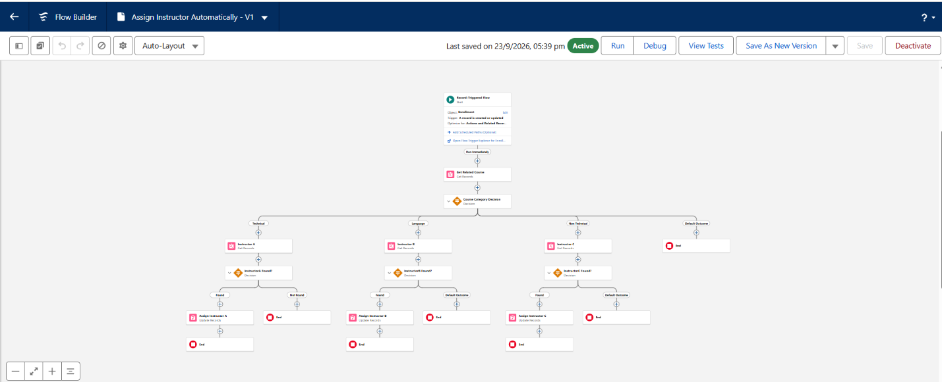

Activity 4: Auto-Create Task for Follow-Up

Purpose:
When Enrollment is “Requested”, create a follow-up task for Admin.

Steps:

- Create Record-Triggered Flow on Enrollment__c.
- Trigger: Record created or updated; condition Enrollment_Status__c = "Requested".
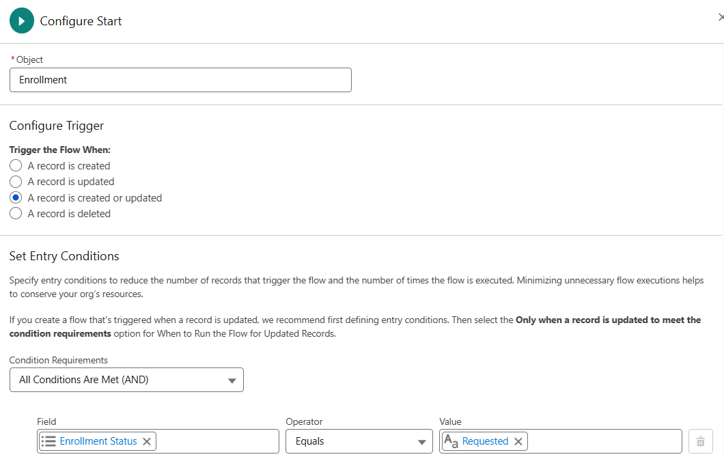
- Add Get Records to fetch Admin user (by Username / Profile).
- Add Formula (Date): TODAY() + 2 for due date.
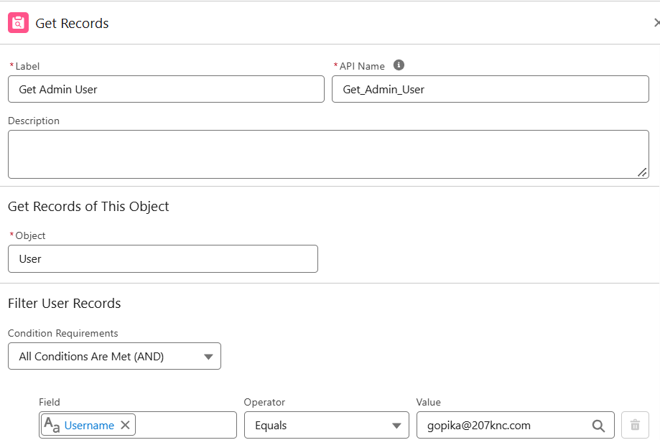
- Add Create Records for Task:
- Subject: Follow up on enrollment request.
- OwnerId: Admin user Id.
- WhatId: Enrollment Id.
- ActivityDate: formula Today + 2.
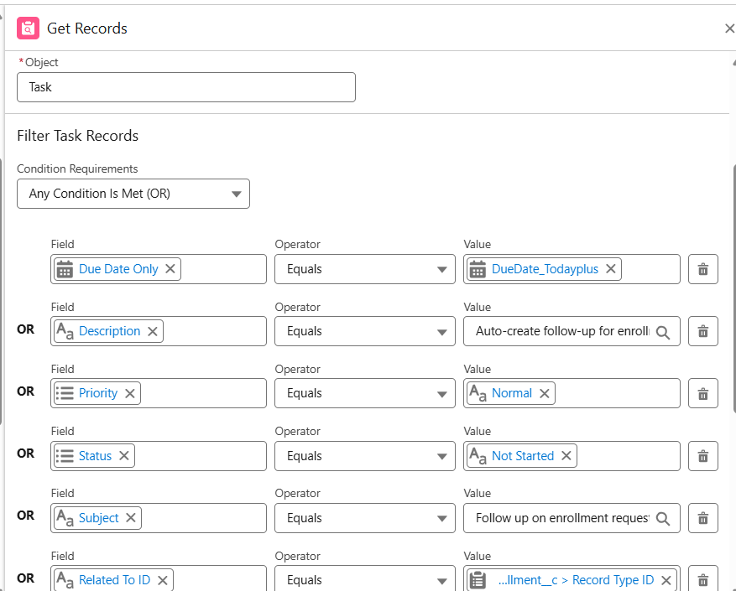
- Save as Create_Followup_Task → Activate.

Milestone 11 – Reports:

Activity 1: Create “Students by Status” Report

1.Go to Reports → New Report.
2.Report Type: Students.
3.Group rows by Status__c.
4.Add columns as needed (Name, Email, Phone).
5.Save as Students by Status.
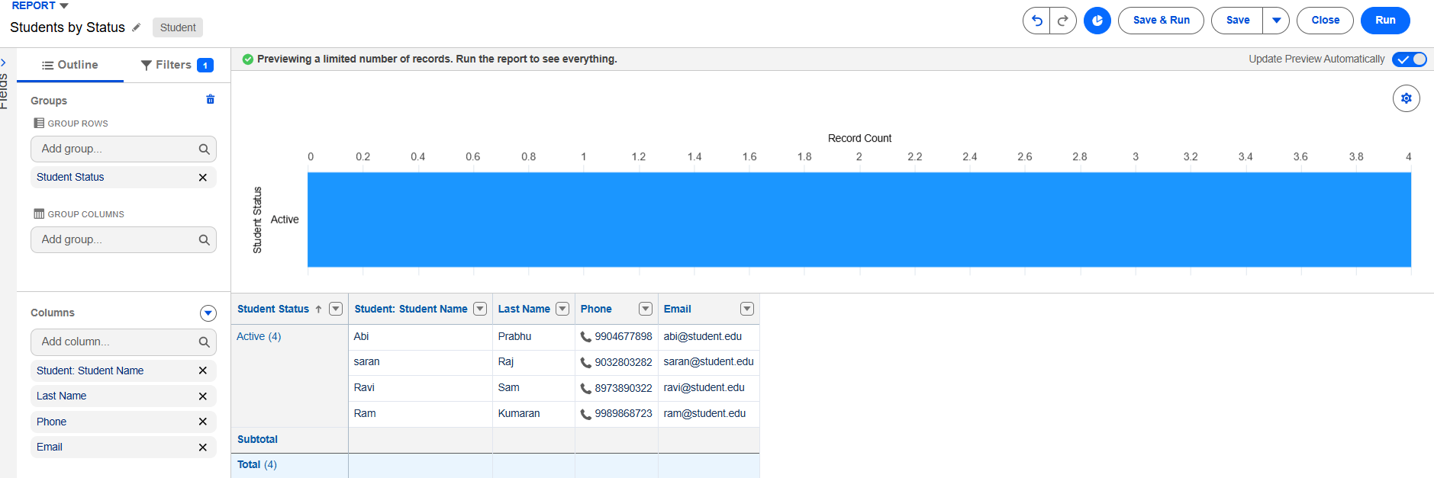

Activity 2: Create “Enrollments by Course” Report

1.New Report → Report Type: Enrollments.
2.Grouprows by Course__r.Name.
3.Show Record Count per course.
4.Save as Enrollments by Course
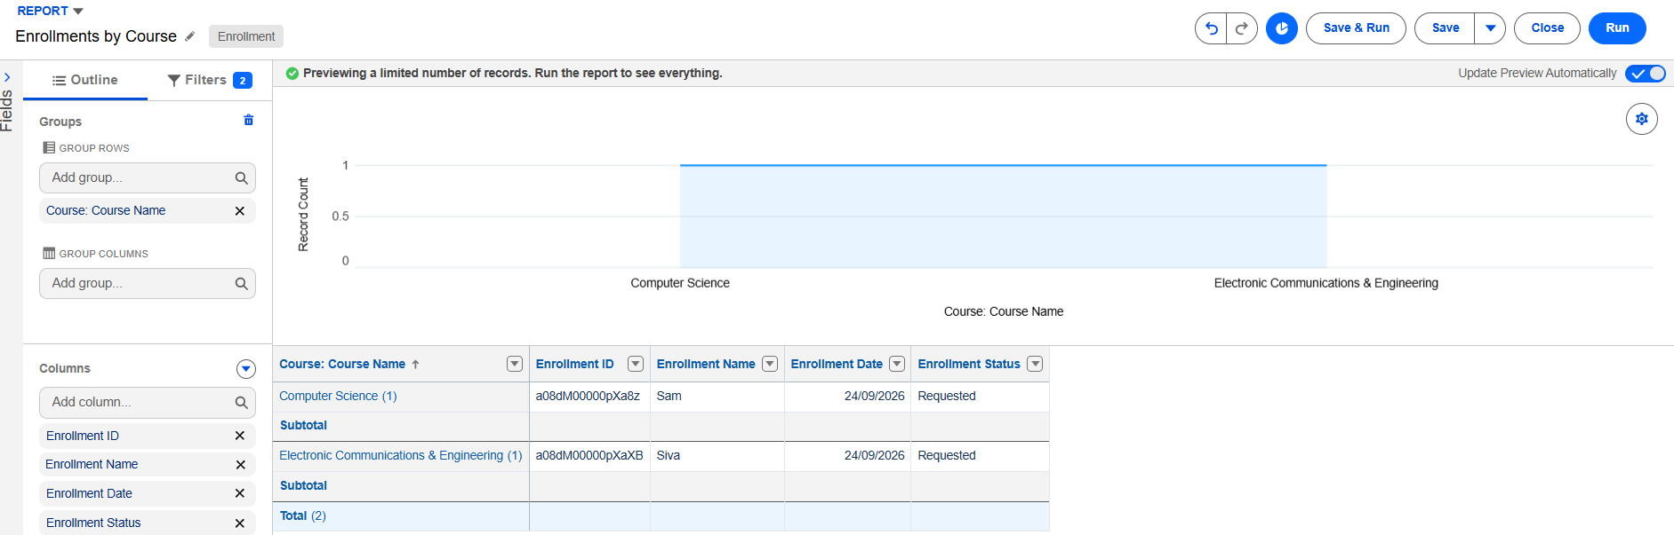

Activity 3: Create “Pending Enrollment Approvals” Report

- New Report → Enrollments report type.
- Filter: Enrollment_Status__c = "Requested".
- Add columns (Student, Course, Owner, Created Date).
- Save as Pending Enrollment Approvals.

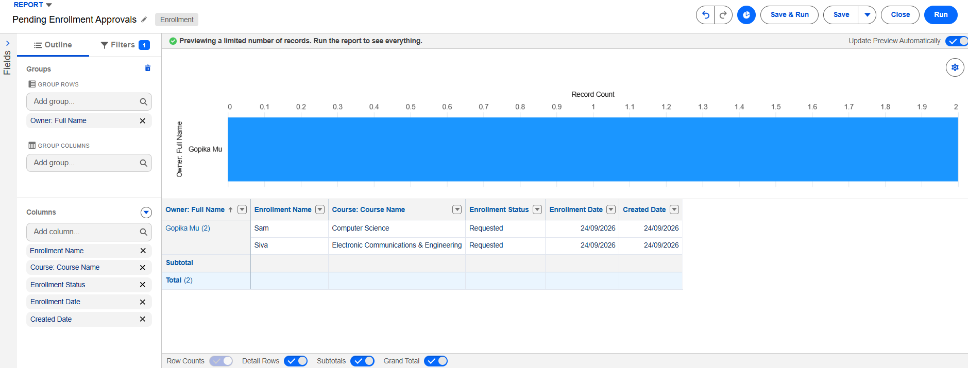

Activity 4: Create “Revenue Report (Fees Paid)” Report

1.New Report → Enrollments report type.
2.Filter: Fees_Paid__c = TRUE.
3.Group by Course__r.Name.
4.Summarize Course_Fee__c or similar fee field.
5.Save as Revenue Report – Fees Paid.
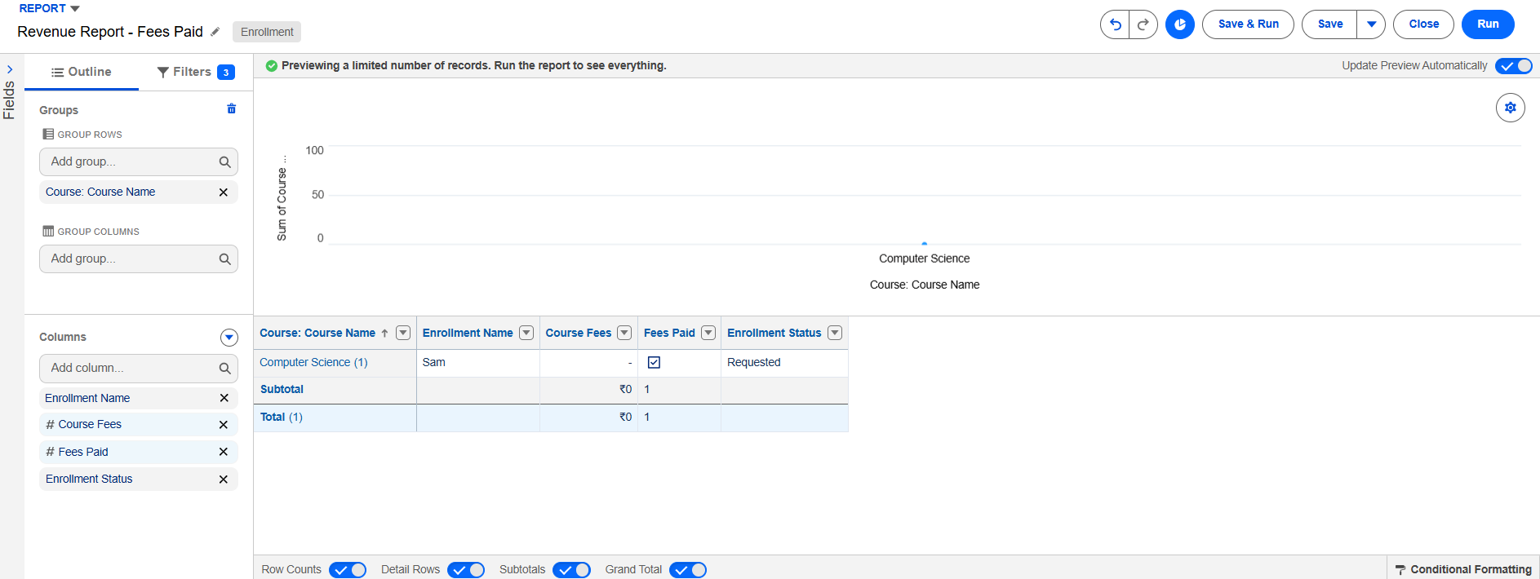

Milestone 12 – Dashboards:

Activity 1: Create “Student Managemet Dnashboard”

Steps:
- Go to Dashboards → New Dashboard.
- Name: Student Management Dashboard.
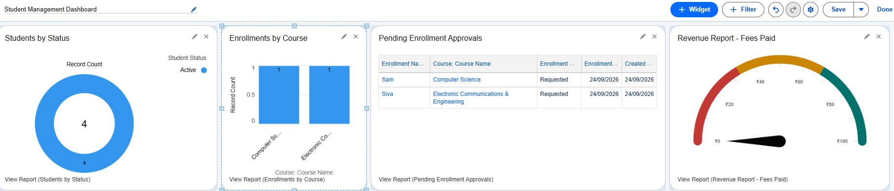
- Select folder → Create.
- Select the new Dashboard folder and Save.
Add components:
- Donut Chart → using Students by Status report.
- Bar Chart → using Enrollments by Course report.
- Gauge → using Revenue Report – Fees Paid (sum of revenue field).
- Table → using Pending Enrollment Approvals report.

- Arrange components on canvas.
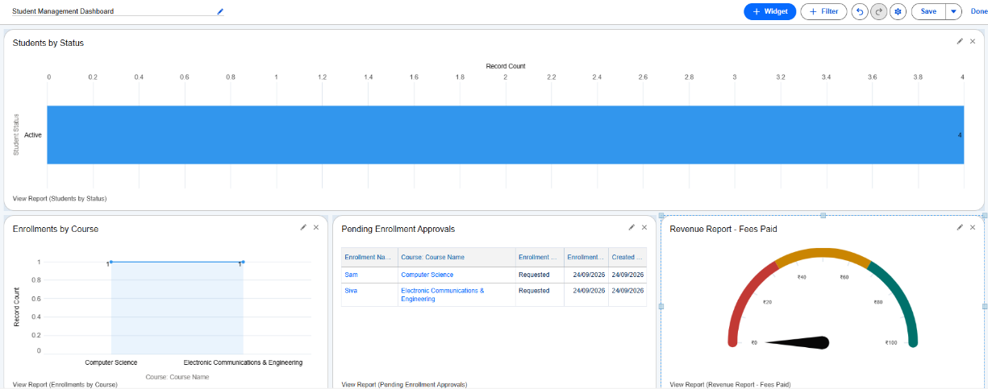
Click Save → Done.

Milestone 13 – Security Setup

Activity 1: Configure Profiles
):
- Go to Setup → Profiles → New (or CloneProfiles Required:
- Admin – Full access.
- Enrollment Officer – Create/Update Enrollments.
- Instructor – Read-only access to assigned Enrollments.
- Steps (example for Enrollment Officer fName: Enrollment Officer.
- In Object Settings:
  - Enrollment__c: Read, Create, Edit.
  - Student__c / Course__c: Read (and Edit if required).
- Save.
Repeat similarly for Instructor profile with Read-Only on Enrollments

Activity 2: Create Permission Sets

- Go to Setup → Permission Sets → New.
- Create Custom Object Access (additional access to project objects if needed).
- Create Dashboard Editor (Create/Customize Reports & Dashboards permissions).
- Assign to relevant users.

Activity 3: Configure Sharing & OWD

Steps:
- Go to Setup → Sharing Settings.
- Set Organization-Wide Defaults:
  - Students (Student__c): Public Read/Write.
  - Courses (Course__c): Public Read/Write.
  - Enrollments (Enrollment__c): Private.
- Save.
For Instructor access to assigned Enrollments, optionally:
- Add a User lookup on Enrollment (Instructor User).
- Use a simple Record-Triggered Flow to set OwnerId = Instructor User so they can see only their own records.

7. FUNCTIONAL & PERFORMANCE TESTING

During the testing phase, screenshots were captured from the Salesforce user interface to verify the proper functioning of all implemented features of the Student Enrollment & Course Management System (SECMS). These include student, course, instructor, and enrollment record creation; validation rule checks for mandatory fields, eligibility, and enrollment constraints; verification of record type behavior for different course categories; flow execution for automated enrollment approvals and seat availability checks; and Apex trigger functionality to ensure automatic confirmation and record updates. Additionally, screenshots of generated reports and dashboards were documented to validate accurate data visualization, enrollment tracking, and performance monitoring. Submit the Screenshots while testing.

8. ADVANTAGES & DISADVANTAGES

Advantages
- Centralized data
- Automated workflows
- Real-time reporting

Disadvantages
- Salesforce dependency
- Requires initial configuration effort

9. Conclusion:

The Salesforce Student Enrollment & Course Management System successfully streamlines the entire student academic lifecycle—from student registration and course creation to enrollment management, instructor assignment, approvals, revenue tracking, and reporting. By leveraging Salesforce’s automation tools such as validation rules, flows, approval processes, and dashboards, the system improves data accuracy, operational efficiency, and decision-making. This project demonstrates how Salesforce can transform manual academic processes into a scalable, reliable, and user-friendly digital solution.

10. FUTURE SCOPE
- Payment gateway integration
- Student self-service portal
- Analytics-driven insights
- Mobile access support

11. APPENDIX
- Source Code: Salesforce Configuration
- Dataset: Salesforce Objects
- GitHub / Demo: Salesforce Developer Org

Thank You

